Escritorio

60

Dept.

129.1
Technical reference Created by Approved by

Fabricio Cuba
Document type

29/04/2021

Document status

Title
ENSAMBLE
DWG No.

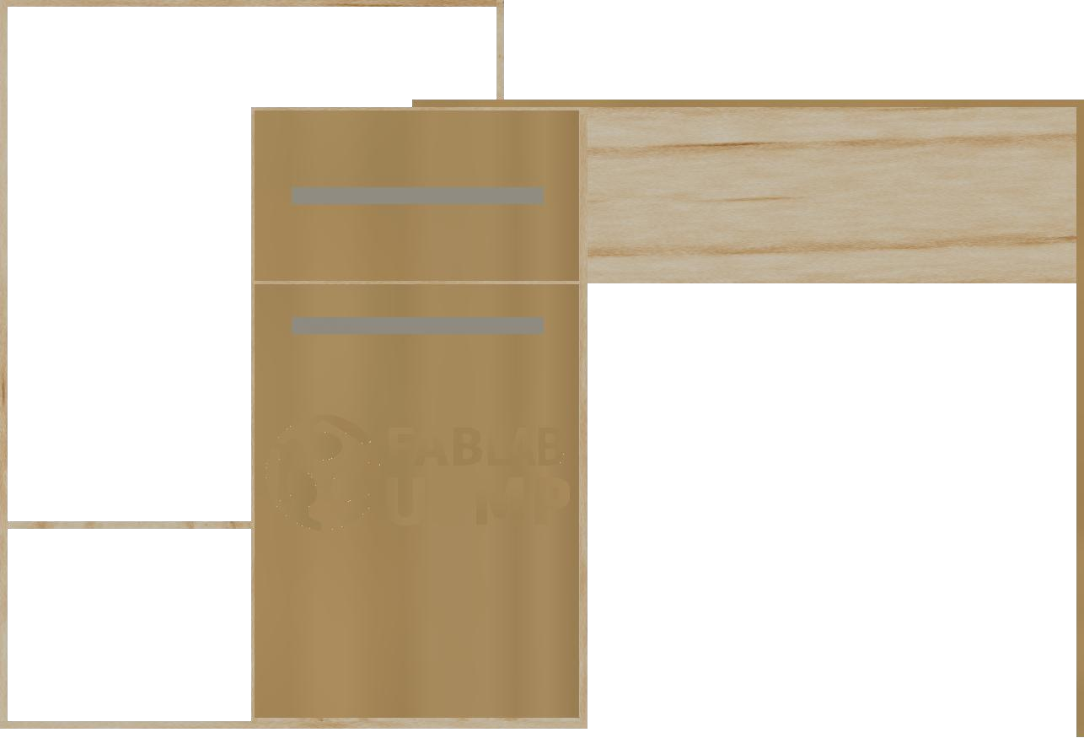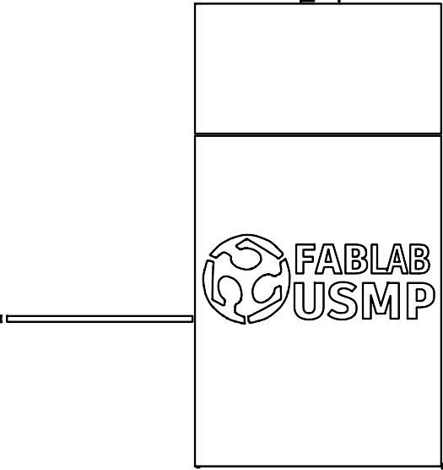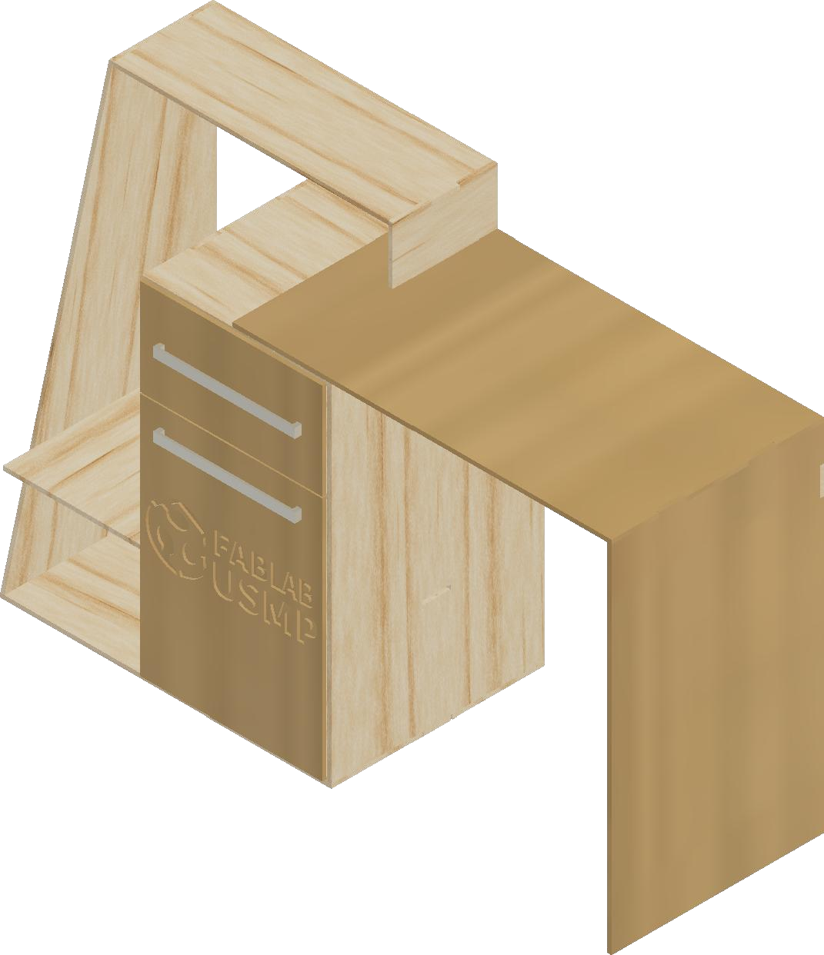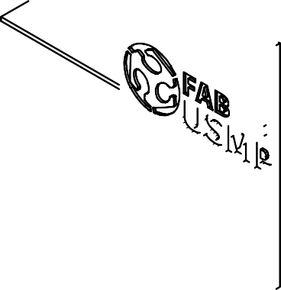Rev.
86.9
75.9
Date of issue
Sheet

1/1

