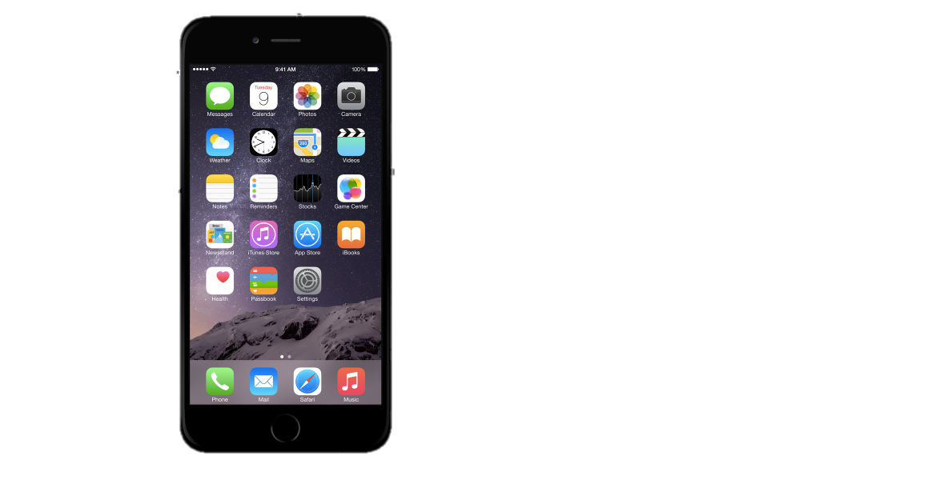



USB case design folio

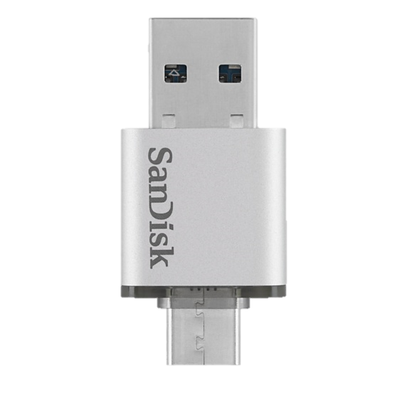
STUDENT NUMBER: 30114086
PROJECT PROPOSAL:
- INDENTIFICATION AND EXPLORATION OF NEED
- AREAS OF INVESTIGATION
- CRITERIA TO EVALUATE SUCCESS

PROJECT MANAGEMENT
- ACTION AND TIME PLAN
- FINANCE PLAN
- SELECTION & USE OF IDEAS AND RESOURCES
PROJECT DEVELOMENT
- EVIDENCE OF CREATIVITY
- CONSIDERATION OF DESIGN FACTORS
- RESEARCH
- EXPERIMENTATION & TESTING
EVALUATION
CONTENTS
CONTENTS

PROJECT PROPOSAL:



(i) IDENTIFICATION AND EXPORATION OF NEED
(ii) AREAS OF INVESTIGATION

(iii) CRITERIA TO EVALUATE SUCCESS

- IDENTIFICATION AND EXPORATION OF NEED

DESIGN STATEMENT
DESIGN STATEMENT

My client, SanDisk approached me with a proposition to design a new product for a Universal Storage Bus (USB) as there is a shortage of sales of the product over the past financial year.
SanDisk is an American manufacturer of flash memory products, including memory cards and readers, USB flash drives, and solid-state drives. As of February 2015, it is third-largest manufacturer of flash memory.
The manufacturer is in possession of a surplus of uncased USB devices and in need of a new method for a consumer to use them while keeping up with rising technology around them. Common issues evident with USB devices are that; they are easy to misplace; have a limited storage; and have trouble competing with new technologies with the same purpose.
As the market for technology is fast paced and constantly changing, an allocation of 8 weeks to design the product was provided by the client, with appropriate testing and research evident to be presented before the production so that the product can be reviewed, then assembled by the end of June 2017.
The budget to have a completed product ready for reproducing is $150 set by SanDisk.
Additionally, SanDisk has requested for the product to promote the ‘SanDisk Memory Zone’ App to use in conjunction as it allows smartphone users to easily browse, select, move and protect all the files on their phone and move files to and from a storage device card to free up phone memory.

DESIGN STATEMENT OVERVIEW

Client: SanDisk
Need: A new method of using a USB device to keep up with current technological trends. May include other common needs of:
- storing a USB so it won’t get lost
- using the SanDisk Memory Zone App to organise files
Product: USB phone case
Purpose: to create a case for a USB
Criteria: needs to store a USB securely
Time: 8 weeks
Budget: $150

DESIGN STATEMENT EVALUATION

I believe USB devices are outdated in modern technology and therefore this task of creating a case for a USB will become invalid/quickly outdate. A new design may interest for short term, but a USB will not be a sustainable and efficient storage in the near-future.

- AREAS OF INVESTIGATION

HOW WILL I PRESENT MY FOLIO?
- Page size and paper type: A4,
- Folio Presentation: The colour scheme of my folio to reflect the SanDisk logo of a dark red colour, represented through titles, clipart, borders and images.
- Use of models and mock-ups: Photos and screenshots of physical and computerised 3D models will be implemented to improve communication of ideas.
- Project materials: All materials will be listed, and factors, such as weight and cost will also be recorded.
- Project testing and experimentation: : Photos and screenshots of the processes will be included, with myself performing the actions as evidence of my own work, and results will be recorded to determine the best technique and material.
- Project production skills and techniques: Photos and screenshots of the processes will be included, with myself performing the actions as evidence of my own work.

WHAT NEEDS TO BE INVESTIGATED?
- Use of models and mock-ups: As a large company in intending to mass-reproduce the item, a completed/furnished model will be presented, as well as a deconstructed model, ready for reproducing in the method of mould and casting.
- Project production skills and techniques: Proposed techniques to create a mould and cast is to 3D print an initial model, then create a mould of that, then lastly cast that model.
- Project materials: Proposed materials for the product is to 3D print a model using a PLA (Polylatic Acid) filament, as it is provided by my school. The mould material that is most likely to be used is a Pinkysil brand mould mixture and casts mixture, as they can be sourced through my school also.
- Project testing and experimentation: Proposed testing and experimentation will include 3D printing, moulding, casting, and making moulds of the 3d oriented materials to see the finish and quality.

WHAT ARE THE BASIC PARAMETRES OF THE DESIGN?
CASTING MATERIALS
DESIGN PARAMETRES
8 GB
LIMITED TO STORAGE
MATERIAL
FUNCTION
AESTHETIC APPEAL
FINISH OUTTER COAT
MOLDING
CAST MATERIAL
34 DAYS PRODUCTION
8 WEEKSS
CASTING
INCLUDE TESTING
$300
TIME
METHOD
COST

WHAT ARE THE POSSIBILITIES OF THE DESIGN?

The possibilities to a design are endless, if they stay within the parameters. Some possible ideas can be:
- Using the USB device for several applications
- Using several different casting materials
- Using other medias rather than just casting

WHAT METHODS CAN I USE TO CONDUCT MY RESEARCH?
Primary Market Research (gather new data), which can be through two forms:
- Exploratory Research
-An open-ended form of research, where a specific problem is defined and usually involves a form of questioning that requires long answers and from a group of respondents.
Methods:
>Interview collective
>Survey
- Specific Research

-A precise investigation used to solve a problem identified by exploratory research.

-Could include interviews with several individuals.
Secondary Market Research (gathering data that already exists):
-Using previous studies and applying the results to a specific situation

Methods:
>Research from text books and internet sources

- CRITERIA TO EVALUATE SUCCESS
- Function- The purpose of a USB is to provide storage. If it does not work for this purpose specifically, it will become idle.
- Aesthetics- The USB needs to be attractive to consumers and able to draw attention to be able to be successful in the market. This may include colour and shape.
- How It Works- The basic function of a USB works by plugging it into a female USB port. The method of using a USB can differentiate, but the way it works stays the same.
- Size- A USB needs to be compact
- Durability- The Product needs to last from wear towards it’s desired use to be sustainable.
- Sustainability- The product needs to be sustainable meaning that it cannot harm the environment during production, have a long-life span, and can be disposed of properly, such as the methods of recycling and upcycling.
- Availability-
- Ergonomics- Refines the design off products to optimize them for human use. All human characteristics, such as height, weight, and also hearing and sight. Ergonomics is also known as human factors in engineering.
- Interactions- The interaction between the product, human use, and other items that the item is likely to come across and how it may affect each of them.
- Cost- The amount to be paid or spent to buy or obtain something.
- Safety- The product has a need to safe for anybody that encounters it.
- Logo- The SanDisk logo needs to be displayed to identify this product as their own.
For this USB, as it is to be mass produced for a wide consumer variety for the most sales, the aesthetics and function are just as important as each other.

PROJECT MANAGEMENT:

(i) ACTION AND TIME PLAN
(ii) FINANCE PLAN
(iii) SELECTION AND USE OF IDEAS
(iv) CRITERIA FOR SUCCESS

- FINANCE PLAN
PART 1 – JUSTIFICATION - PRODUCT
PHONE SHELL
SERIAL | RESOURCE | JUSTIFICATION
1 | Polylactic Acid (PLA) Filament – Black | - Cheap material to produce models  - Strong material  - Lightweight  - Biodegradable  - Derived from renewable resources  - Black hides impurities  - Insoluble in water
2 | Epoxy Bond | - Industrial strength for permanent bond  - Rapid drying after application  - Bonds high range of materials  - Reasonably cheap
FRONT CASING
SERIAL | RESOUCE | JUSTIFICATION
3 | PLA Filament - Dynamite red | - Cheap material to produce models  - Strong material  - Lightweight  - Biodegradable  - Derived from renewable resources  - Red Relates to SanDisk logo and colour theme  - Insoluble in water
BACK CASING
SERIAL | RESOURCE | JUSTIFICATION
4 | PROCAST Polyurethane Resin | - Excellent flow  - General Shore 65D Hardness range  - Rapid setting  - Compatible with range of moulding materials  - Excellent detail production because of it’s low viscosity  - Easy 1:1 mix ratio by weight  - Low setting exotherm temperature
5 | BJB Black Pigment | - Only very small amount needed  - Cheap, relative to how much each container can be used  - Easy to apply to resin
6 | Apple Lightning to USB Adapter | - Bought piece as it is safer for myself around electricity and the iPhone to not ruin the power outlet.
2 | Epoxy Bond | - Industrial strength for permanent bond  - Rapid drying after application  - Bonds high range of materials  - Reasonably cheap
USB CASING
SERIAL | RESOURCE | JUSTIFICATION
4 | PROCAST polyurethane Resin | - Excellent flow  - General Shore 65D Hardness range  - Rapid setting  - Compatible with range of moulding materials  - Excellent detail production because of it’s low viscosity  - Easy 1:1 mix ratio by weight  - Low setting exotherm temperature
7 | USB Stick | - Essential as it is what case Is based around
2 | Epoxy Bond | - Industrial strength for permanent bond  - Rapid drying after application  - Bonds high range of materials  - Reasonably cheap
PART 1 – JUSTIFICATION – TOOLS
MOULDS
SERIAL | RESOURCE | JUSTIFICATION
8 | Pinkysil Silicon Rubber | - Easy usability  - Quick setting  - Easy 1:1 mix ratio by weight  - Fine detail mould making  - Skin safe
9 | Disposable Plastic Cup | - Small amount of waste to dispose of for one mould
10 | Digital scale | - High precision strain gauge sensor to the nearest gram  - Low battery/overload indication, to know if it is fully functioning  - Tare function  - All durable plastic construction is easy to clean and portable to store
11 | Dual Material 3D Printer | - Extremely easy method to create products and prototypes with precision, and the ability to duplicate them  - Relatively cheap to maintain  - Relatively easy to transport devices

PART 2 – INDUVIDUAL PURCHASES
SERIAL | ITEM | QTY. | Bulk Cost/Unit | Cost/Unit | Amount required | SUB TOTAL
1 | PLA Filament - Black | 1 | $45/ | $0.10/g | 93g | $9.30
2 | Epoxy Bond | 1 | $4.95/5ml | n/a | 5ml | $4.95
3 | PLA Filament – Dynamite Red | 1 | $45/ | $0.10/g | 3g | $0.30
4 | PROCAST Polyurethane Resin | 1 | $77/2kg | $0.06/g | 34g | $2.04
5 | BJB Black Pigment | 1 | $16.45/50ml | n/a | 2ml | n/a
6 | Apple Lightning to USB adapter | 1 | n/a | $9.00/u | 1 unit | $9.00
7 | USB Stick | 1 | n/a | $7.00/u | 1 unit | $7.00
8 | Pinkysil Silicon Rubber | 1 | $132/2kg | $0.66/g | 210g | $13.86
 |  |  |  |  |  | TOTAL COST
 |  |  |  |  |  | $46.45

- SELECTION AND USE OF IDEAS AND RESOURCES

TIME: Time is a very precious resource, I will need to ensure that I keep up at an efficient pace to finish in time. I have 8 weeks to work with, and I need to complete my other subject tasks and my design folio during this time.

FINANCES: Although my project is small in scale, a lot of items may have to be purchased to make a finished product, and for testing and prototypes. My budget set is $150 so I need to stay under that amount.
COMPUTER: In this project, most of the work is to be done through my computer using different software to make a detailed project.

SKETCHUP 3D MODELLING SOFTWARE: This will be the main software tool that I am to use. It can be used to created detailed 3D models easily, and I have used this software in the past so it is a good choice.

AUTOMAKER: This software will be used to 3D print my models through. Because of the brand of 3D printers available, this is the best choice as it is made by the same company for ease of use.

(iv) CRITERIA FOR SUCCESS
CRITERIA FOR SUCCESS

The criteria for success guiding the design process of the product is to result in a successful project which includes the following information:

- Criteria:
- A new method of using a USB device for storage
- Case to be produced for the product
- Design that is not easy to lose the product due to it’s small size
- Water resistant

- Function:
- Functional USB for storage uses
- USB used in conjunction of the ‘SanDisk Memory Zone’ App

- Aesthetics:
- SanDisk logo on product
- Quality finish of the casing on the product
- Design to keep up with current fashion trends of the type of product.

PROJECT DEVELOPMENT:

- EVIDENCE OF CREATIVITY .
- CONSIDERATION OF DESIGN FACTORS .
- RESEARCH .
- EXPERIMENTATION & TESTING .
- FINAL SOLUTION

- EVIDENCE OF CREATIVITY
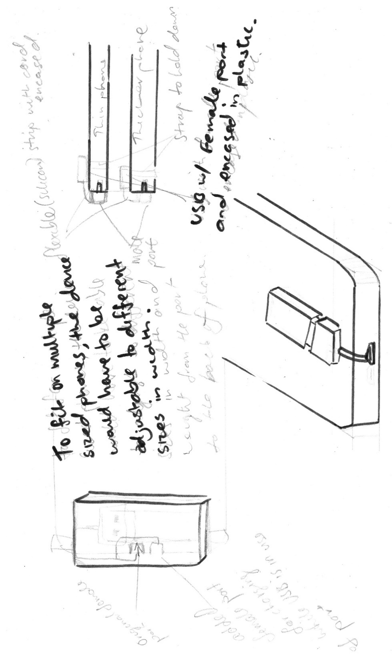
IDEAS GENERATION

This sketch was the initial idea for the USB case as I was looking for a higher purpose for the USB, rather than become dated technology in a short time having the same use as in the past. This sketch entails a setup of a USB connecting to a smart phone for use of extra storage, as a lot of phone don’t have the feature of inserting extra storage through SD cars slots.
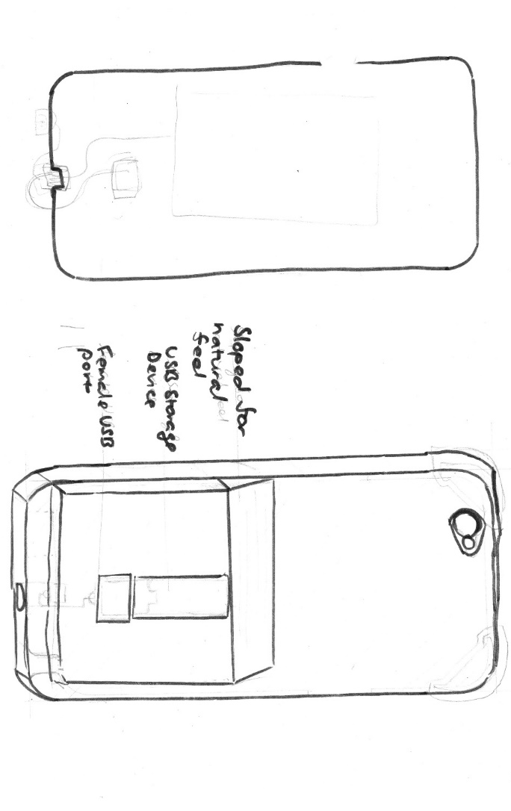
This is similar from the first idea, but the USB and cord are encased in a plastic shell for storage and protection, with a slop for ergonomics, making a natural feeling slop rather than an edge at the top.

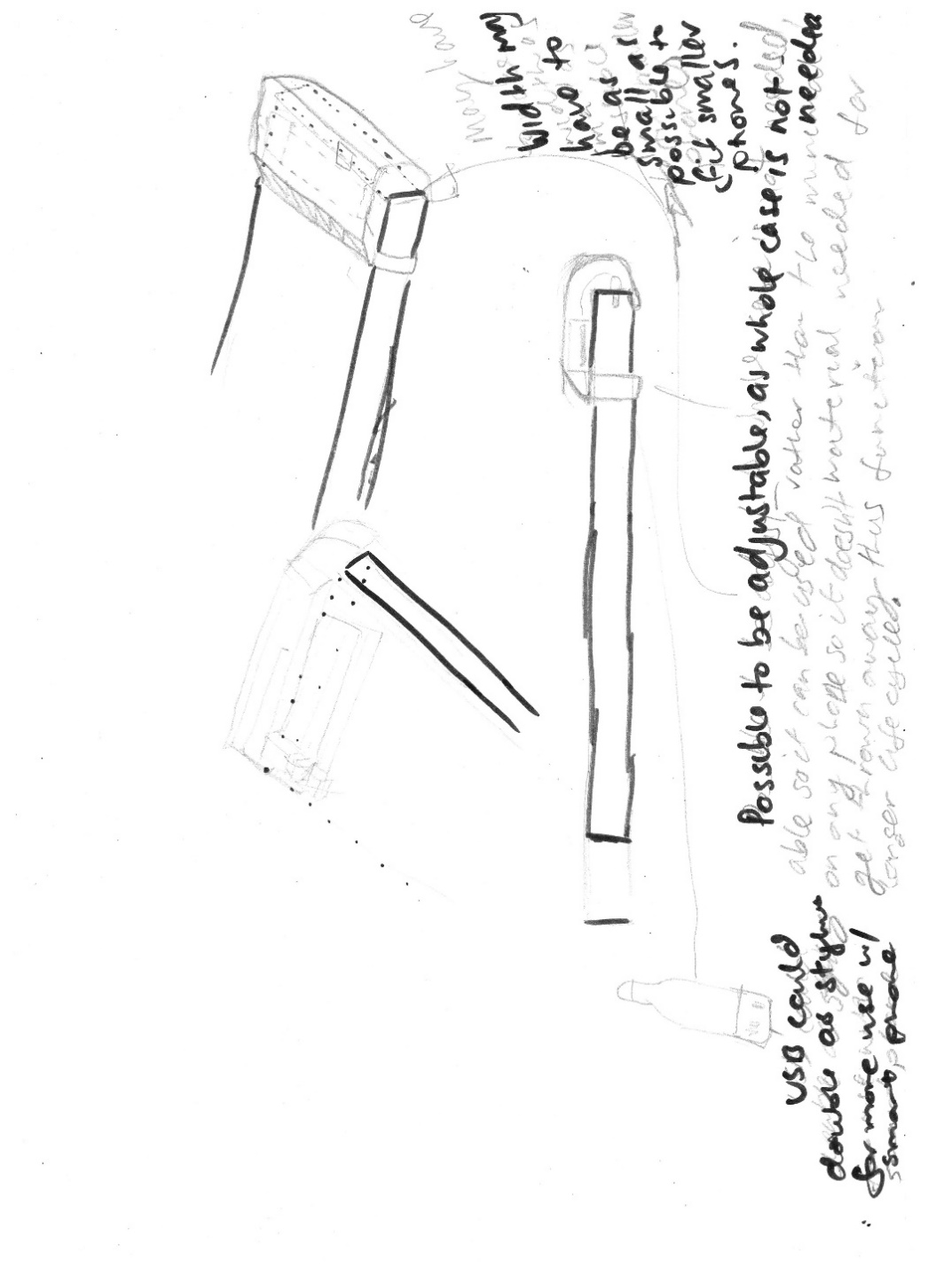

The next idea has the same function, but is a lot smaller in size as it is minimized to only encasing the USB and cord and nothing else, creating less of a bulk compared to the last idea. The problem found with this was that creating a set up that could adjust around any phone case was deemed difficult with the limited technology and materials available compared to a professional manufacturer that would easily create a more furnished and functional product and with higher budgets.
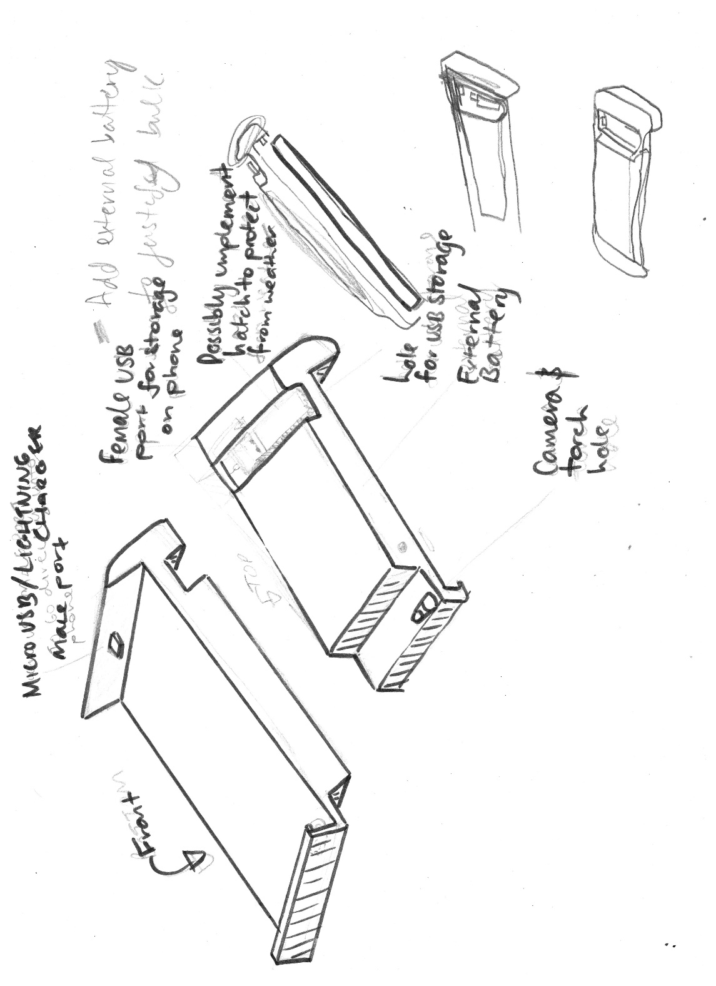
This idea, as a development from the previous, entails a whole phone case, that contains that adapter cord completely rigid inside it. The is a space for any USB to fit in and the idea of adding an external battery, to justify for the bulk given by the USB. The external battery didn’t seem safe to fidget with the power cord to split it to a female USB adapter and a battery cord as I have no experience with electrical cords.
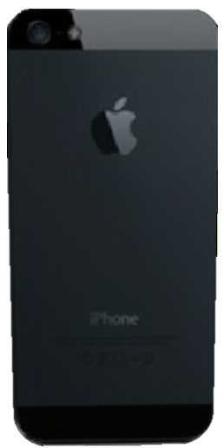
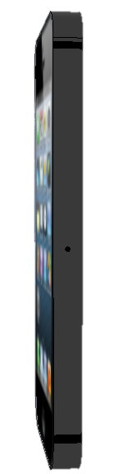
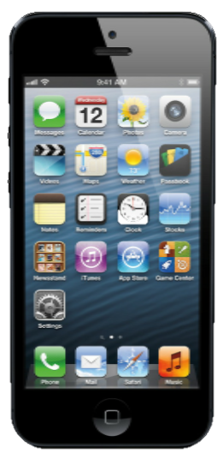
To further develop my ideas, I created models on SketchUP 3D Modelling Software. These helped me communicate my ideas better. I started with a community-made model of an iPhone 5 to base my case around as it has square edges and therefore be easy to model around. This model was made by the community author, Luis. R.
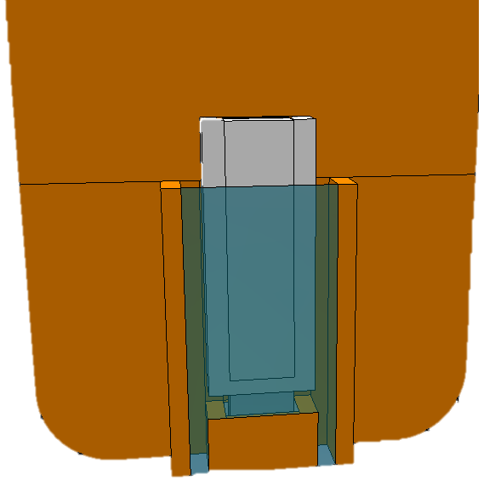
From the iPhone 5 model, I created a basic design of how the USB would slot into the phone. This rear-view angle of the phone displays the basic idea.
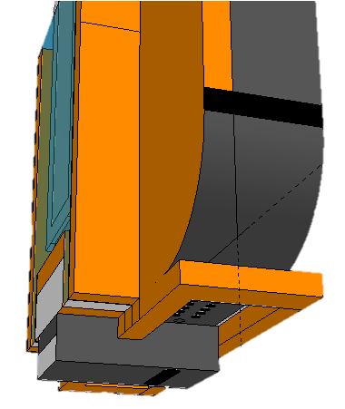
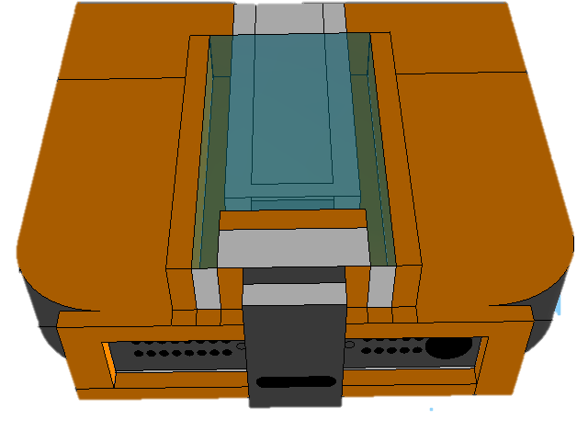
The overhang of the USB storage can be seen in this angle, with the box giving an impression of an unnatural feel.
This lower angle shot displays the casing of the cord going under the phone, inside the grey box. The idea of also having an extra port was also thought of to allow charging at the same time as accessing the USB
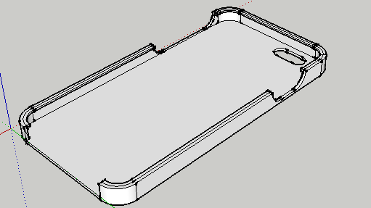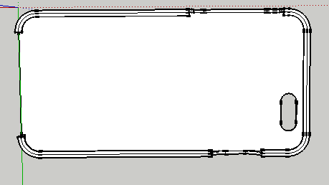
After the survey conducted, it was found that most people surveyed, owned an iPhone 6/6s. The model was downloaded from the community model warehouse on SketchUp as a generic phone case, and was modified by myself to fit an iPhone 6/6s and this model was decided to be the base phone case for my product.

(ii) CONSIDERATION OF DESIGN FACTORS
RECYCLE, REUSE, UPCYCLE, BIODEGRADE

EFFICIENT
FORM
MAUFACTURING
SHAPE/FORM
SIZE
MATERIALS
SUSTAINABLE

SINGLE
CONTINUOUS
BATCH
CUSTOMER REQUIREMENTS
SURVEY/ QUESTIONAIRE
CUSTOMER SPECIFICATION
LOGO
STYLE
QUALITY
IMAGE OF SANDISK
COMPANY IDENTITY
MANMADE
NATURAL
PRODUCTION
MATERIALS
COLOUR
$150
AESTHETICS
ERGONOMICS
ENVIRONMENT
COST
PRODUCT DESIGN
(iii) RESEARCH

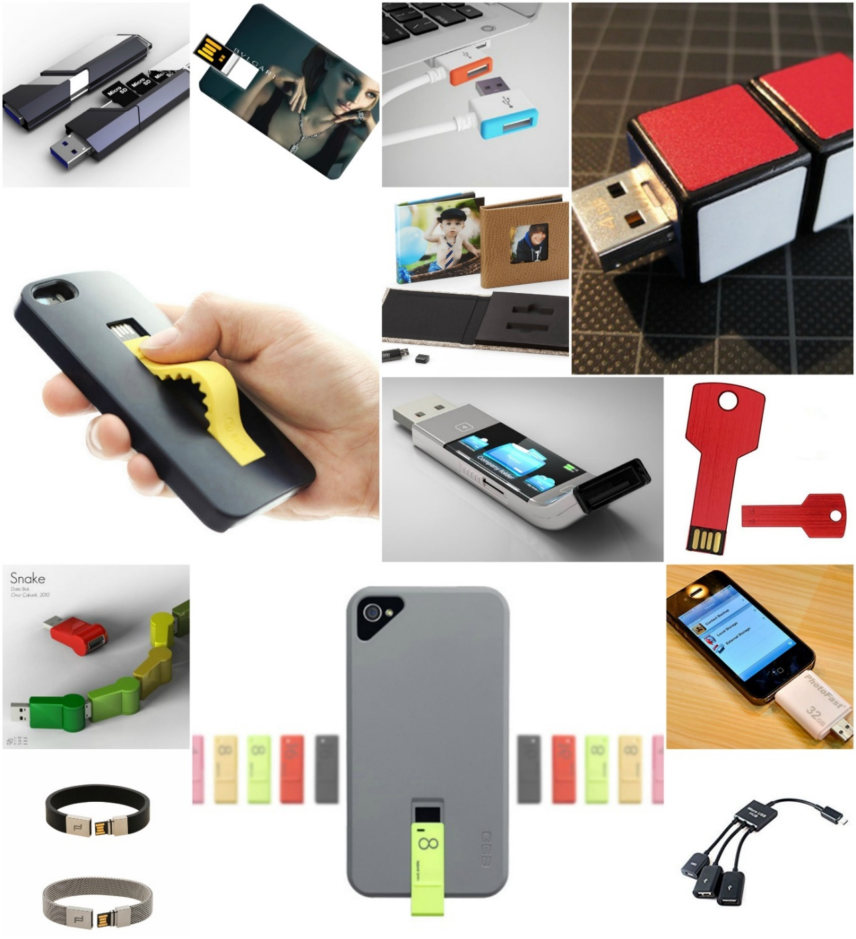
PAST SOLUTIONS:

SOLUTION 1: COMBINATION MEMORY
The USB flash drive accommodates several small capacity memory cards (Micro SD). If the capacity of a memory card is not large enough for use, it becomes idle. This USB design combines several small capacity cards into a larger capacity through a USB flash drive.  http://www.yankodesign.com /2011/04/11/combination-memory/ | 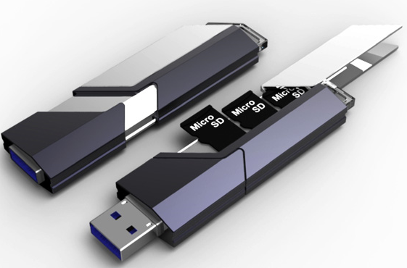
INFLUENCES  Implementing several storage devices together  Reuses older/idle technology into a more modern use. | POSITIVE  ‘Futuristic’ design  Reuses technology  Compact  The male USB port can be protected | NEGATIVE  Possibly easy to lose as it is so compact and the colour theme is not bright

SOLUTION 2: PORSCHE DESIGN MEMORY BRACELET

This design has translated the traditional USB stick into a wearable fashion. The design entails a male USB, a female lid and a silicon or metal wrist band. The Porsche Design logo is placed on the lid.  http://carsandlife.net/2014/- 12/porsche-design-bracelet-usb-memory-christmas-gift-idea.html | 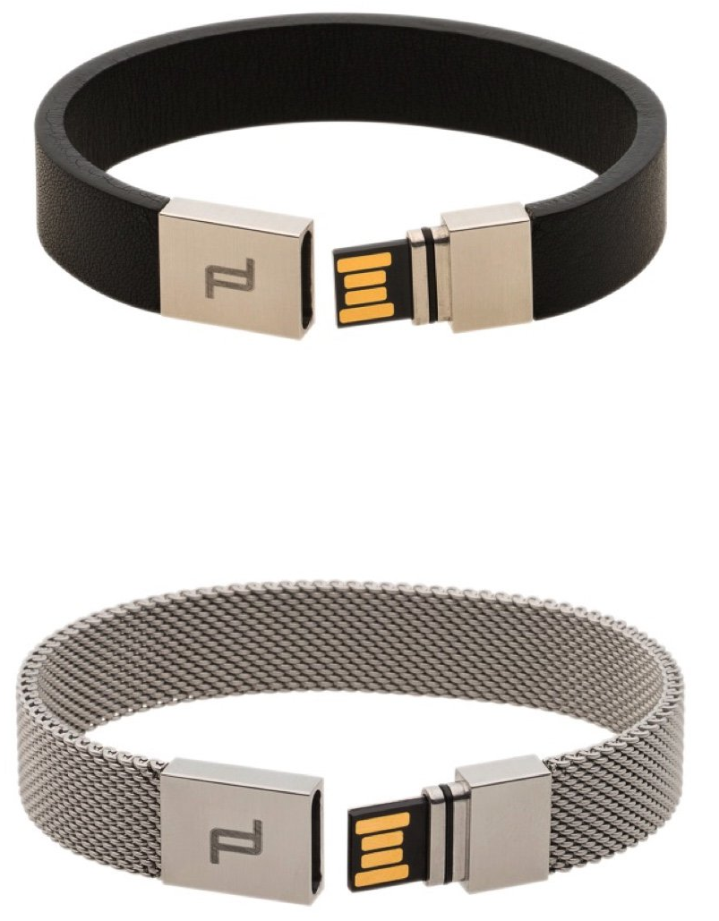
INFLUENCES  Logo displayed on front  Wrist band design means that it is not easy to lose  Minimalist design looks furnished | POSITIVE  Wrist band design means that is not easy to lose  Furnished design | NEGATIVE  Logo is not very identifiable

SOLUTION 3: USB DRIVE HOLDER WITH CAMEO COVER

This method of presenting image files is through a photo album style influenced with technology. The cover encases two USB devices for a professional presentation with a variety of cover designs.  https://www.bayphoto.com /presentation/usb-drives-cases/ | 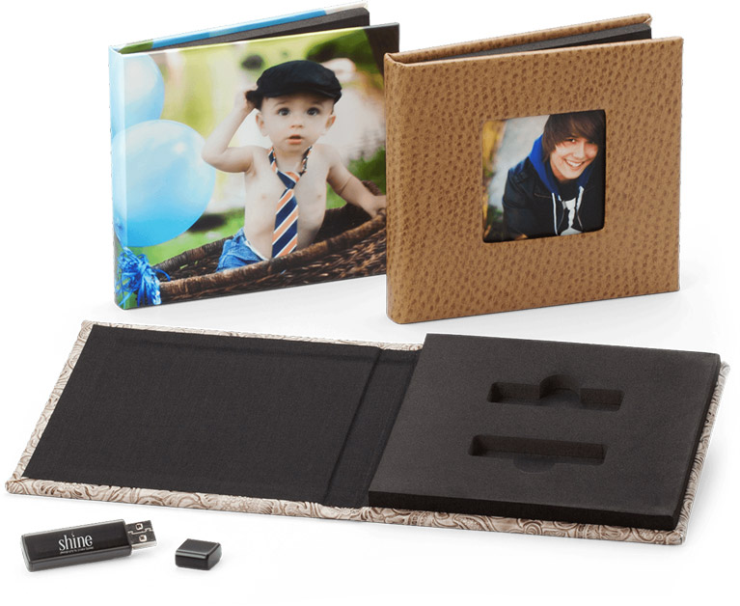
INFLUENCES  Professional folder/album look  Adds a second case with the album cover rather than just on the USB itself | POSITIVE  Professional folder/album look | NEGATIVE  Very uncondensed design for two small USB flash drives

SOLUTION 4: MICRO USB HUB

This adapter cord, entails a male micro USB, splitting into 2 female USB type A, and a female micro USB. | 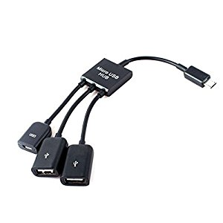
INFLUENCES  This adapter allowing a phone to be connected to USB devices gives the USB’s another spot to use. | POSITIVE  Multi-ports for several uses and means not as many different cords need to be carried. | NEGATIVE  Bulky set-up
PAST SOLUTIONS EVALUATION
The idea of implementing several storage devices has really interested me as it is not common to reuse old/idle technology for further purposes as most of the time a new product is just completely reproduced. This idea may be a major solution for my client.
MATERIALS INVESTIGATION
MATERIAL | PROPERTY | USE IN MY PROJECT
PLA Filament | - Cheap material to produce models  - Strong material  - Lightweight  - Biodegradable  - Derived from renewable resources  - Black hides impurities  - Insoluble in water | Could be used to manufacture any part of my project for modelling and as the product as it is cheap and easy to make things out of. It can also be moulded easily with some brands of moulding. High availability as it is supplied by school and accessible at school during school hours.
Epoxy Bond | - Industrial strength for permanent bond  - Rapid drying after application  - Bonds high range of materials  - Reasonably cheap  - Colourless | Can be used to glue all the final pieces together if needed.
Super Glue | - Fogs many finishes on plastics  - Rapid drying after application  - Bonds high range of materials  - Reasonably cheap  - Good strength | Can be used to glue all the final pieces together if needed.
ProCast Polyurethane Resin | - Excellent flow  - General Shore 65D Hardness range  - Rapid setting  - Compatible with range of moulding materials  - Excellent detail production because of it’s low viscosity  - Easy 1:1 mix ratio by weight  Low setting exotherm temperature | Most likely be used for whole product or parts to cast models of for the final product. High availability as it is supplied by school and accessible at school during school hours.
Pinkysil Silicon Rubber | - Easy usability  - Quick setting  - Easy 1:1 mix ratio by weight  - Fine detail mould making  Skin safe | Most likely to be used for whole product or parts for making moulds of for the final product. Highly accessible as it is supplied by the school.
Apple lightning charger to USB adaptor | - Allows a USB device to plug into an iPhone 5th generation and above  - Can be bought in several length cords | Can be used if product is aimed towards iPhones rather than Android phones to connect the USB.
Micro USB to USB Type A adapter | - Allows a USB device to plug into any Android phone  - Can be bought in several length cords | Can be used if product is aimed towards Androids rather than iPhones to connect the USB.
USB Stick | - Allows external storage from a device | To be used to base the product around to provide external storage to a phone.

TOOLS INVESTIGATION
TOOL | USES | USE IN MY PROJECT
ROBOX Single Material 3D Printer | 3D-print the PLA filament into 3D objects | 3D-print the PLA filament into models, prototypes and final product.
Digital scale | Measure various weights of objects | Weighing the Pinkysil moulding mixture and ProCast mixture ready for use.
Disposable Plastic Cup | Contain a liquid or substance | Mix Pinkysil and ProCast in.
Spray Paint Can | Used to spray compressed paint | Paint glossy coating onto the final pieces of my product

SURVEY
I created a survey aimed at high school students to determine the biggest need for phone storage on several types of smartphones
Mobile Phone Survey
Survey for results to be used in my Design and Tech class. Please fill out
What type of smartphone do you own?
- iPhone
- Android
- I own a feature phone/ non-smartphone
- I don't own a mobile phone

What model of phone do you own?
- iPhone 4s
- iPhone 5/5c
- iPhone 5s
- iPhone 6/6 plus
- iPhone 6/6s plus
- iPhone 7/7 plus
- Samsung Galaxy S7
- Samsung Galaxy S6
- Samsung Galaxy S5
- Samsung Galaxy note 5
- HTC One
- OPPO F1s
- Other:

Do you have/ever had storage issues with storage on your mobile device? If so, which type of device?
- iPhone, YES
- iPhone, NO
- Android, YES
- Android, NO
- Feature phone/ non-smartphone, YES
- Feature phone/ non-smartphone, NO
- I don't own a phone.
Do you have a case on your phone? And if so, do you like it?
YES and YES
YES and NO
NO and YES
NO and NO

What aspects of phone cases/ specific phone cases do you like?
The look of it
The feel of it
Storage on them
Protection from drops
Water resistance
Other:

What year are you in?
7
8
9
10
11
12
Other:

The survey contained 50 respondents.
The results of this survey showed that more than half (70%) of the responders own iPhones.
Out of all the respondents, 50% own an iPhone 6/6s.
65% of all respondents own an iPhone AND have storage problems.
80% of respondents have a case on their phone while 50% don’t like their cases.
100% of respondents that own cases like the look of cases, 100% like the protection of cases and 85% like the feel of their cases.
It was determined from this research that I would base my product around iPhones due to their lack of storage.
(iv) EXPERIMENTATION AND TESTING

Experiment 1: Mould finish quality
- Aim: to determine the quality of the finish given to a mould from a 3D printed object.
- Equipment:
  - ROBOX Single Material 3D Printer
  - PLA filament
  - Pinkysil
  - 3x Disposable Plastic Cup
  - Icecream stick
  - Kitchen Scales
  - Blutack
  - Scalpel
- Method:
  - Create a 3D cube using Sketchup
  - Export model to AutoMaker software and 3D print
  - Measure a 1:1 ratio of the Pinkysil mixture, Part A and B in separate cups, then mix together.
  - Place a small amount of blutack to the bottom of the cube and stick to inside bottom of the last cup.
  - Poor the Pinksil into the cup, in a slow continuous strand.
  - Leave until set.
  - Use scalpel to cut mould in half.
  - Inspect results of finish in mould.
- Conclusion: It was determined that Pinkysil moulding is very detailed at reproducing 3D objects.
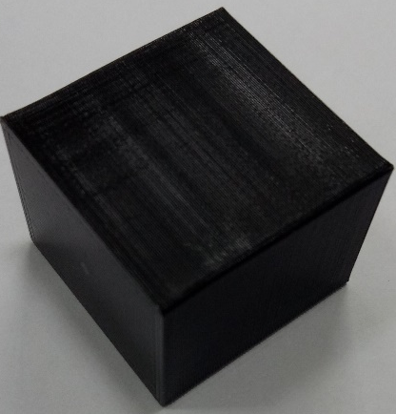
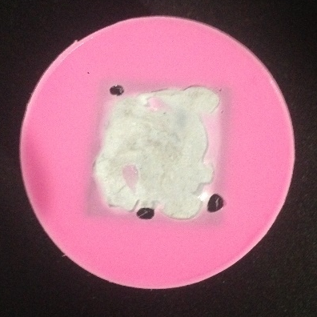
Figure 1credit: Luis R. - Sketch Up community model
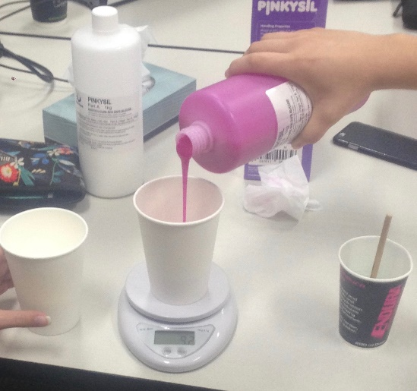

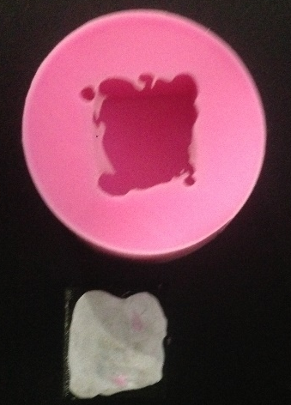

(v) FINAL SOLUTION

LIGHTNING CHARGER
CAMERA HOLE
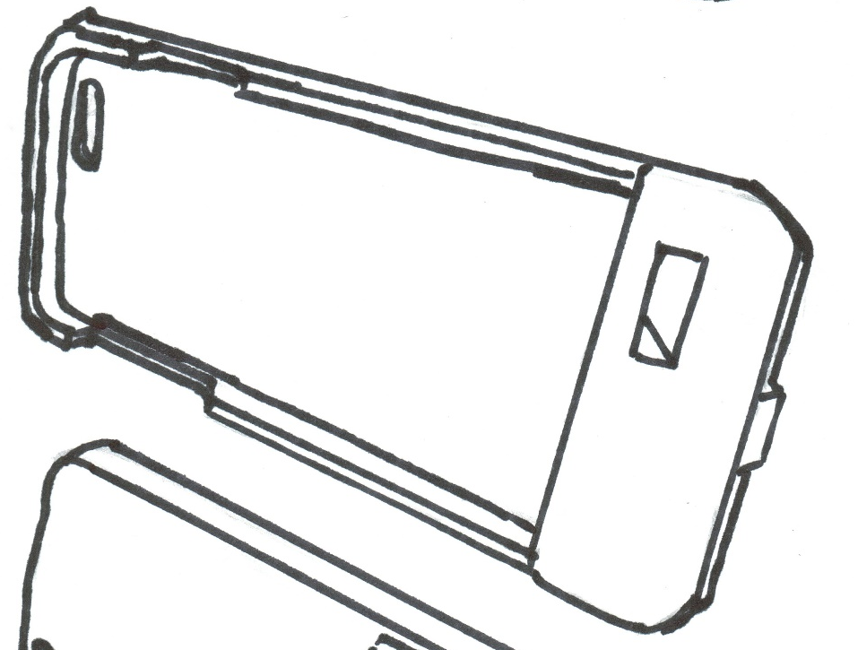
SPEAKER HOLE

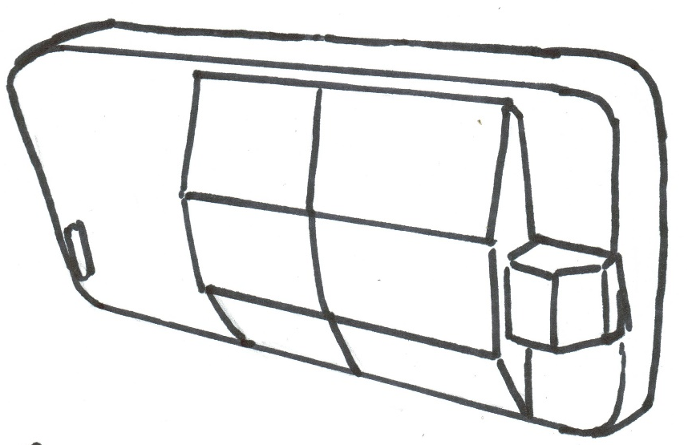
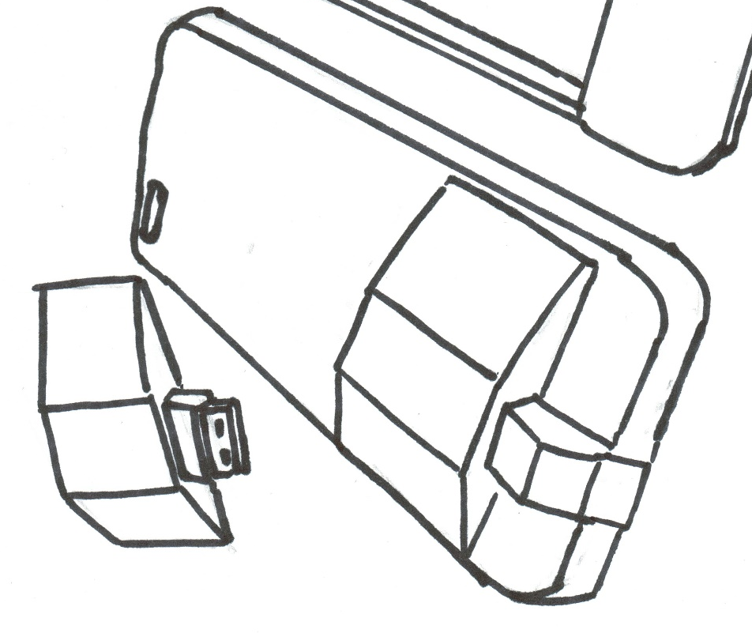
USB CASING
USB CASING
FRONT CASING
BACK CASING
FEMALE USB

METHOD OF CONSTRUCTION
STEP 1: A community-made 3D object of a generic smartphone case was modified to fit an iPhone 6/6s through SketchUp 3D modelling software.
Step 2: At the bottom of the phone case, a section of 26mm long was added as displayed in the green, and the bottom edge of the phone was push down further. A divider was drawn in.
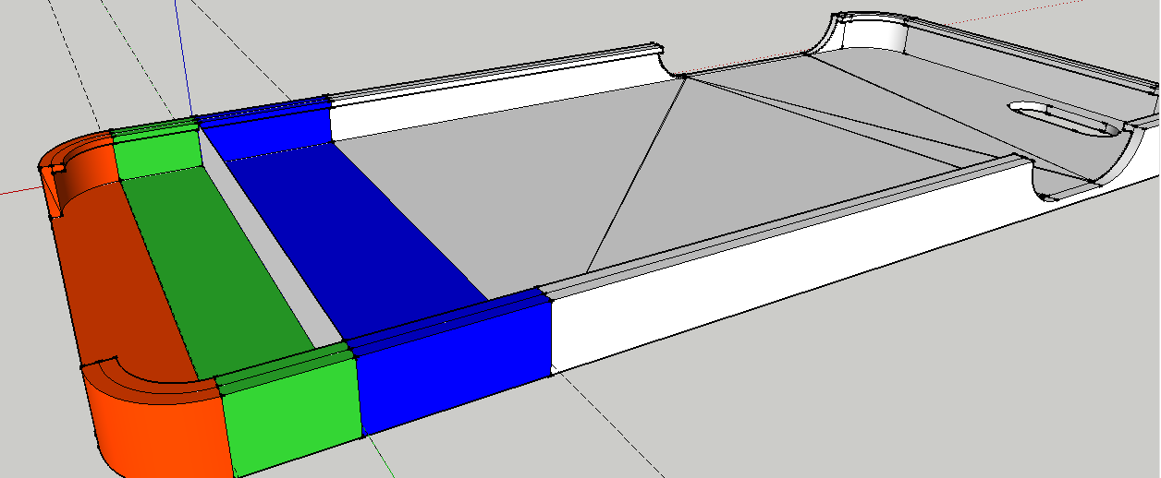

Step 3: The divider was split into quarters, with the centre being the placement of the charger port of the iPhone 6/6s. A rectangular shape with curved sides was measured and cut out.

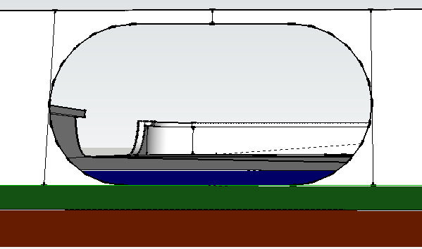
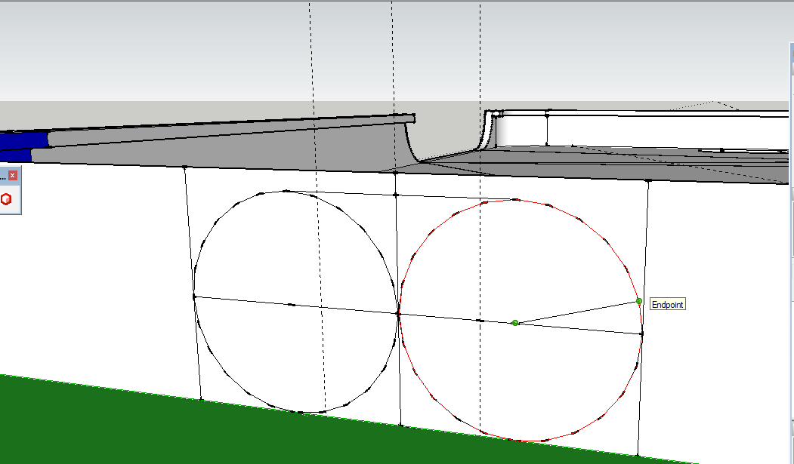
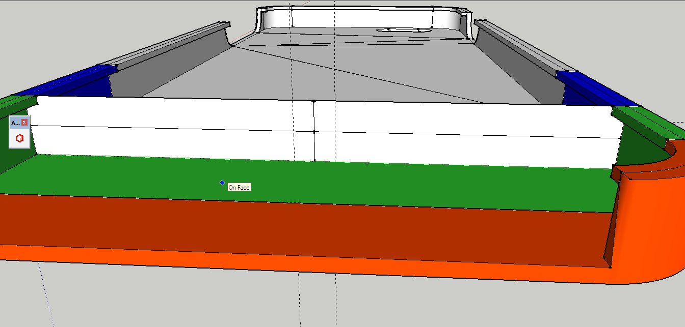

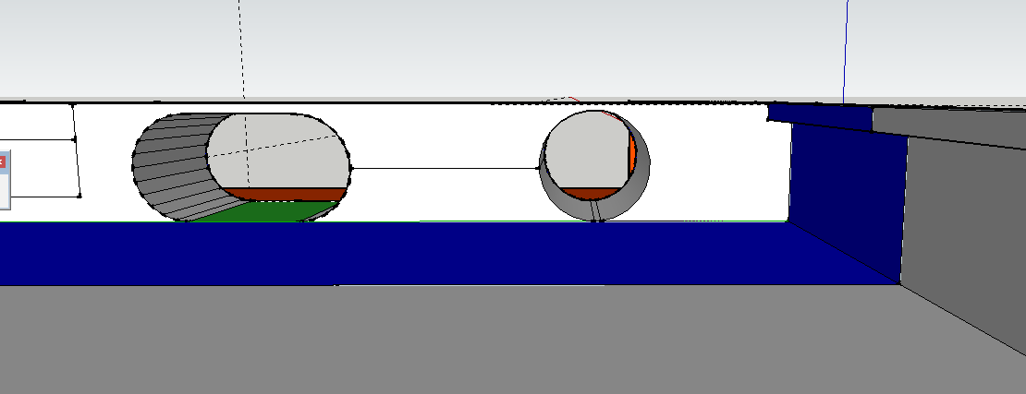
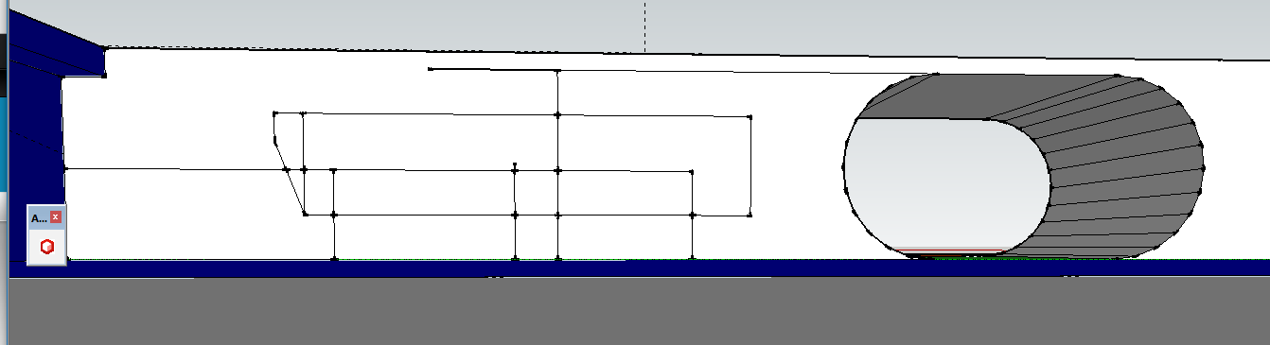
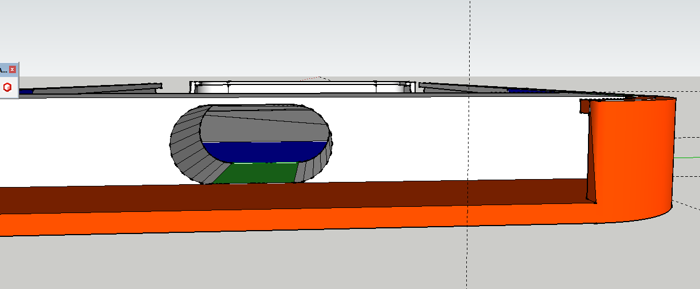
Step 4: The hole was extruded, and the earphone hole was marked out.

Step 5: The hole for the cord to go through was made.
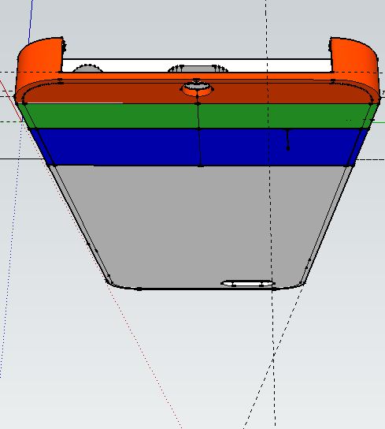
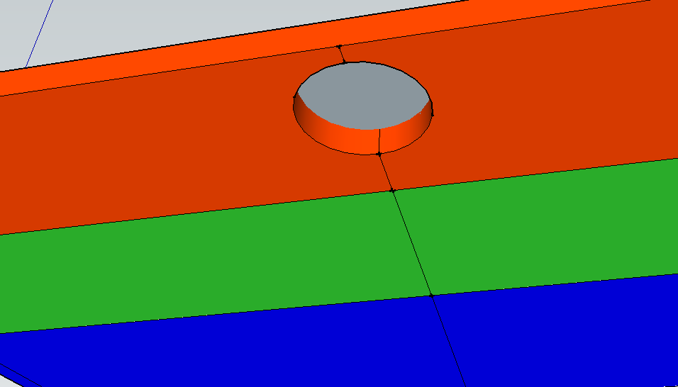

Step 6: Speaker hole was created and earphone hole was expanded.

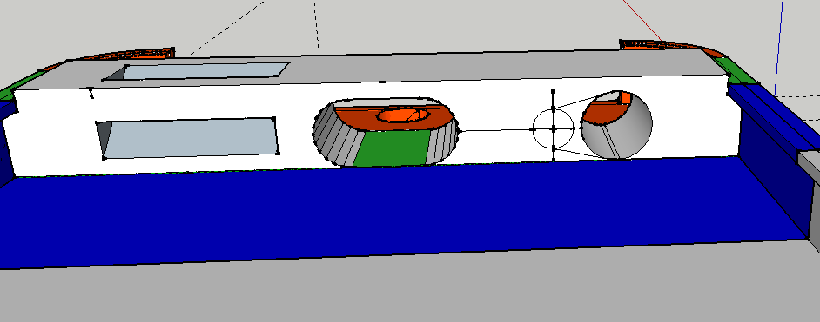

Step 7: The Solid Inspector tool was used to make the phone case a fluid object, meaning I had to remove all inside walls and lines. 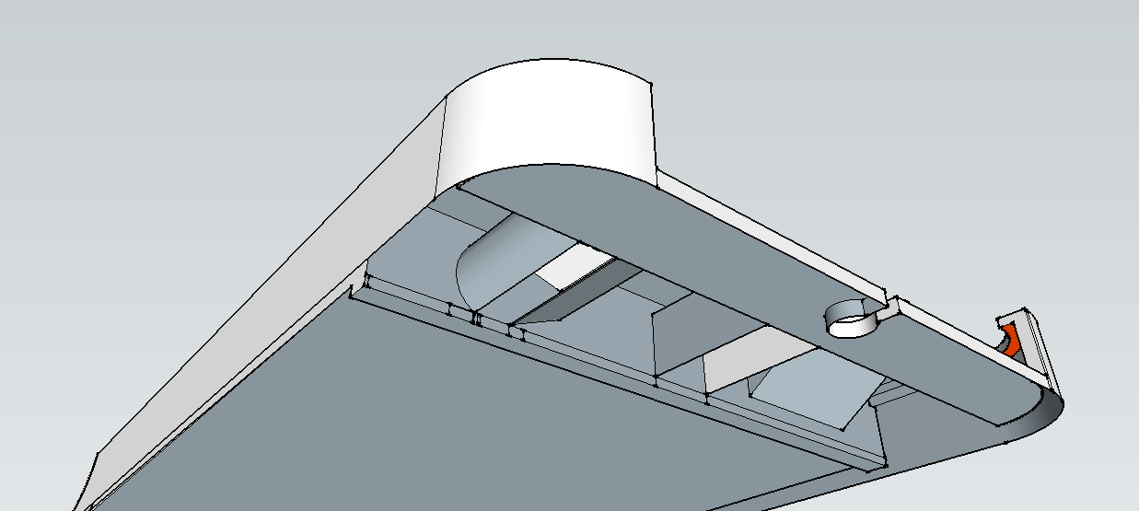
Step 8: The model was exported in ‘STL’ format and imported to AutoMaker ready for 3D printing.
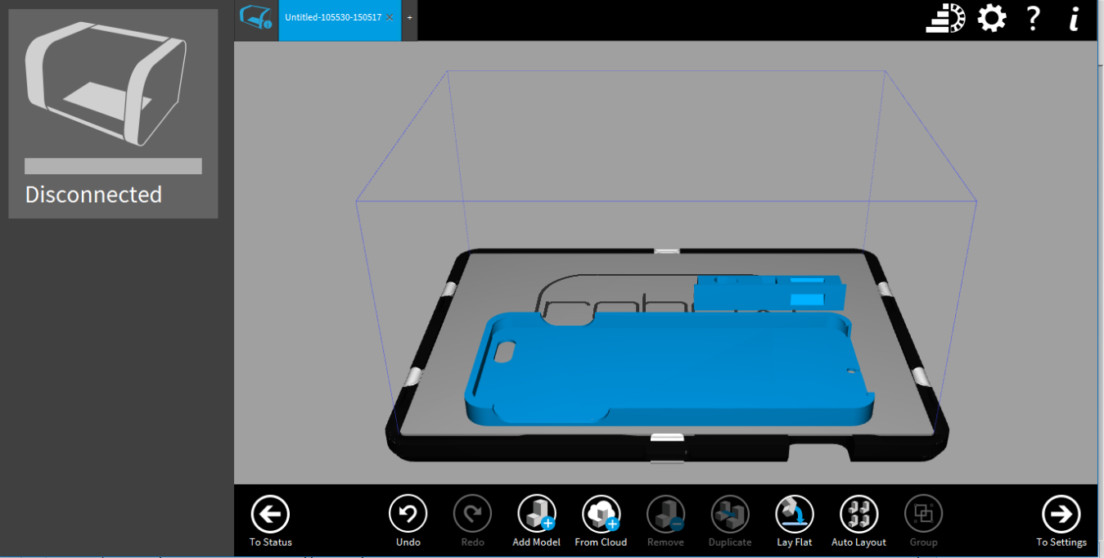
Step 9: The back casing of the phone that will hold the cord was measured out, drawn and extruded. The smaller end was sloped and a top was put on.

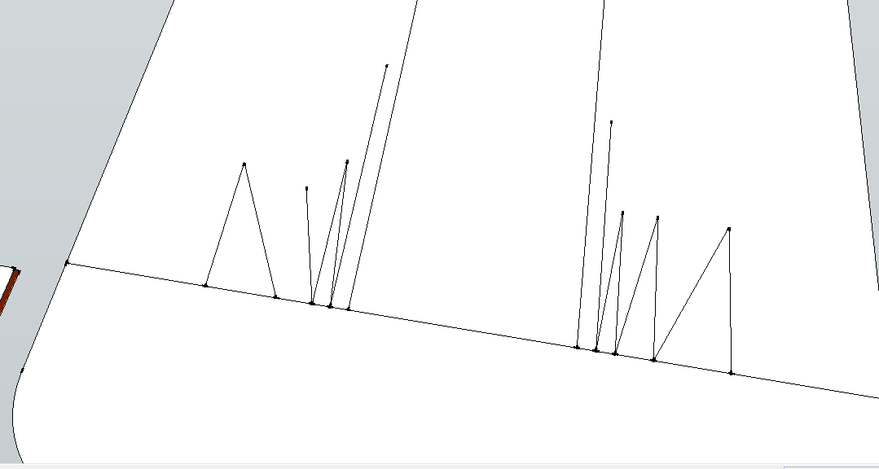
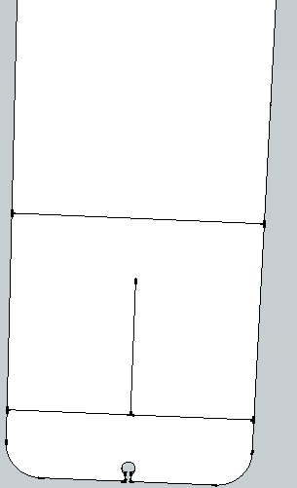
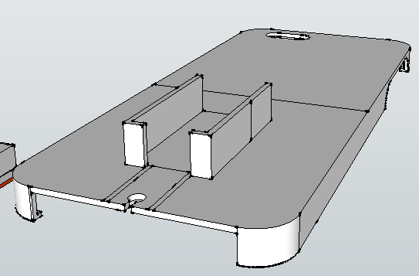

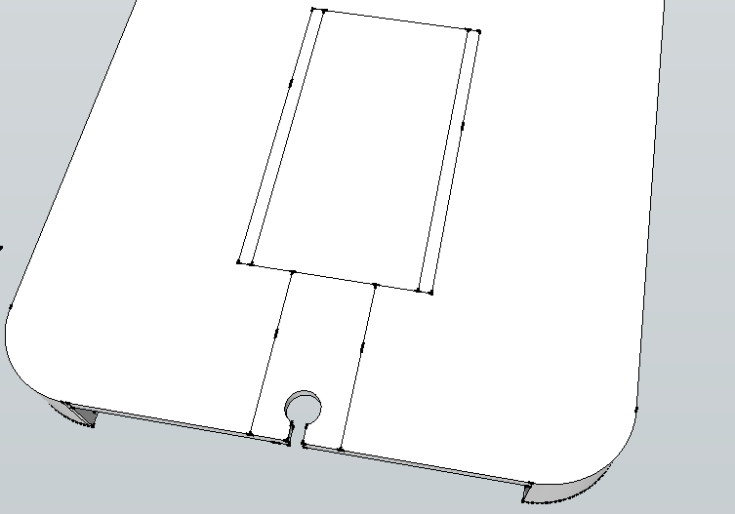
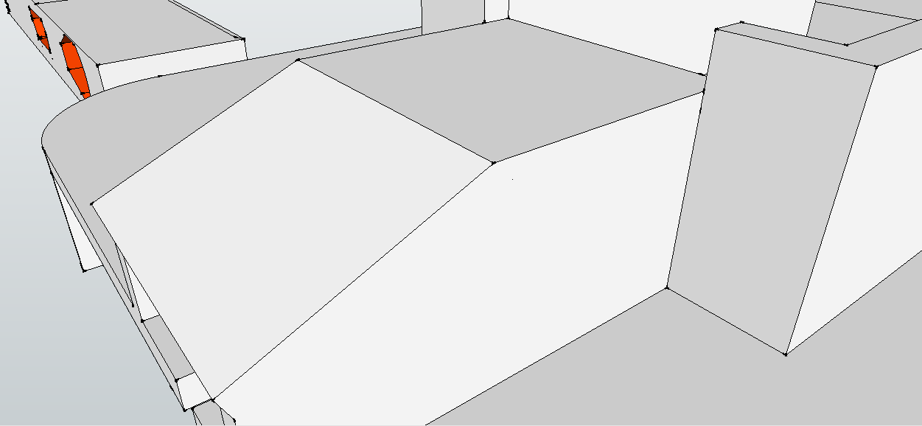
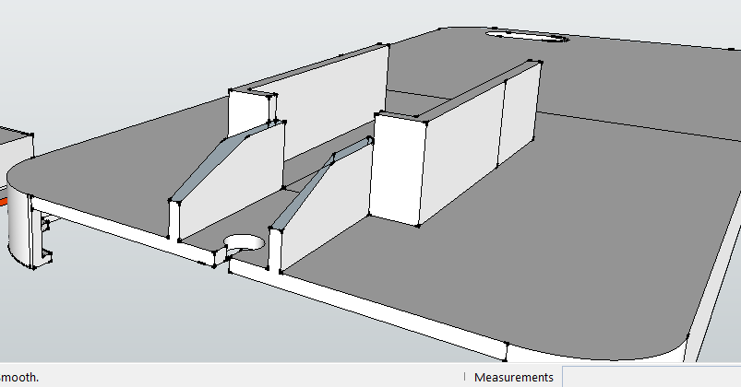

Step 10: The USB shell was modelled off the back casing to keep the right sizing.

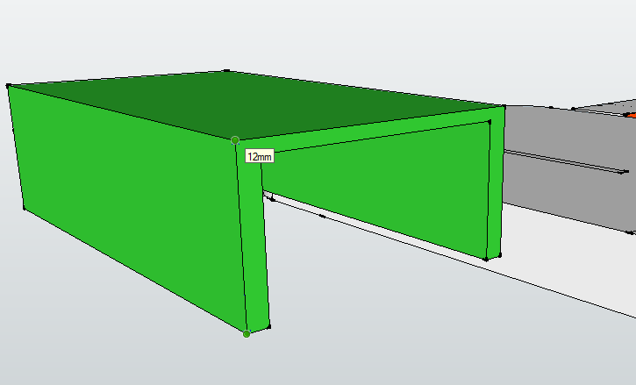
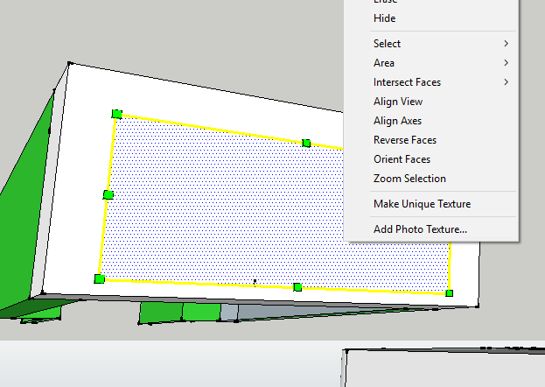

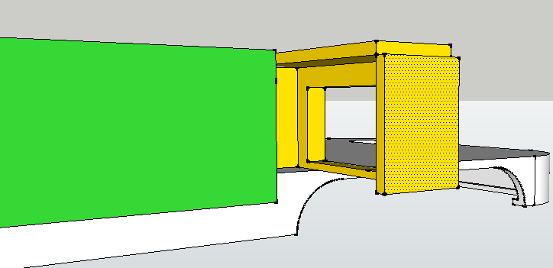
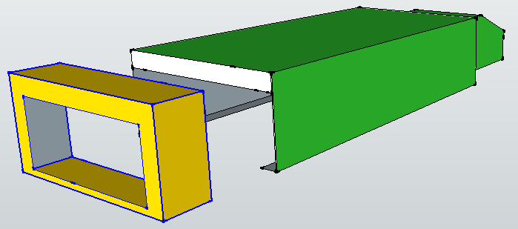

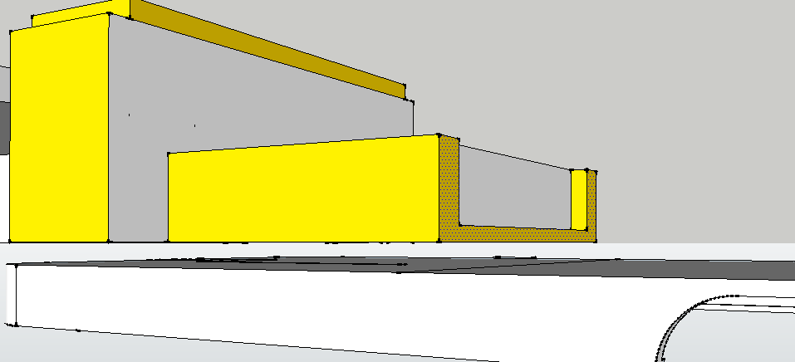
Step 11: Slopes were created off the sides of the back casing for a more naturak feel. The are almost as wide as the phone case. The same action was used on the USB case. A slot was made for the USB case to fit tightly into the back casing for extra strength.
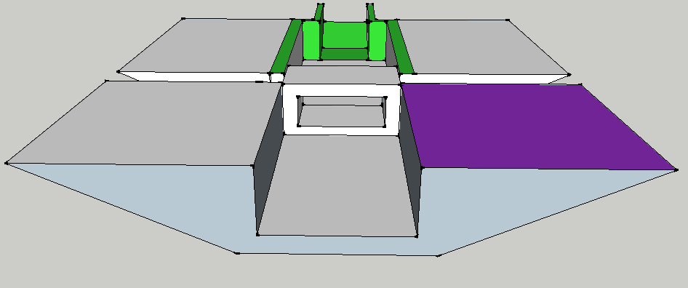
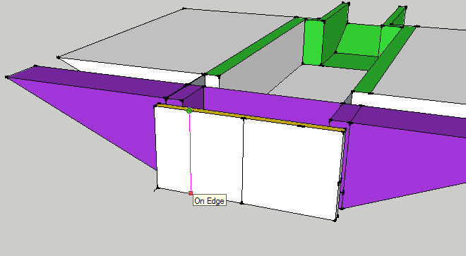
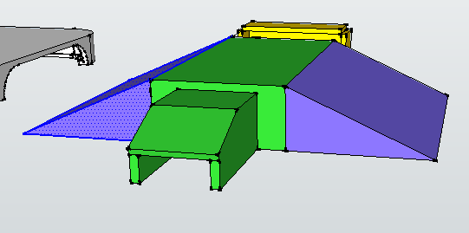
Step 12: The back casing and USB casing were exported in STL format and imported to AutoMaker to be 3D printed.

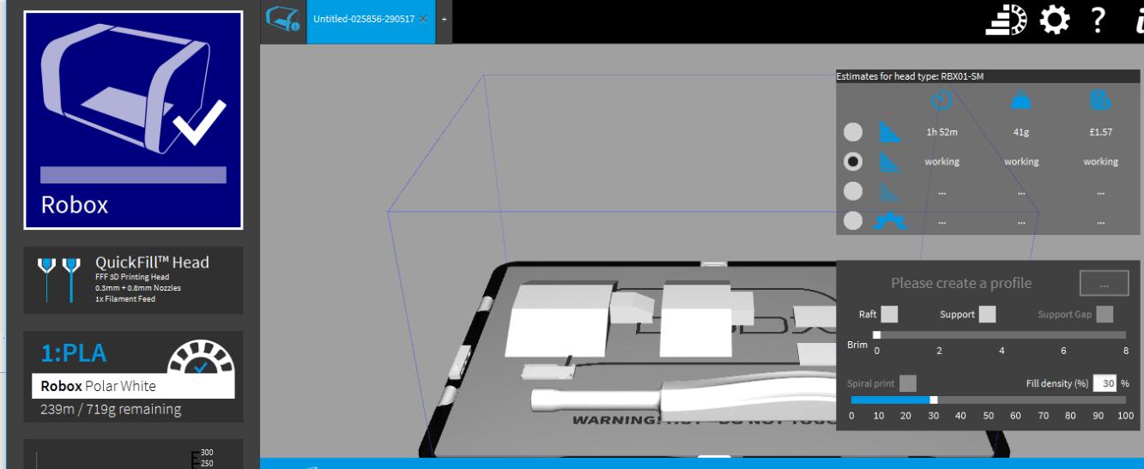

Step 13: A Front cover was created off the front of the phone and removed, then exported and 3D printed.
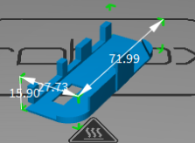

Step 14: The 3D printed objects were removed from the printer.
The phone case:
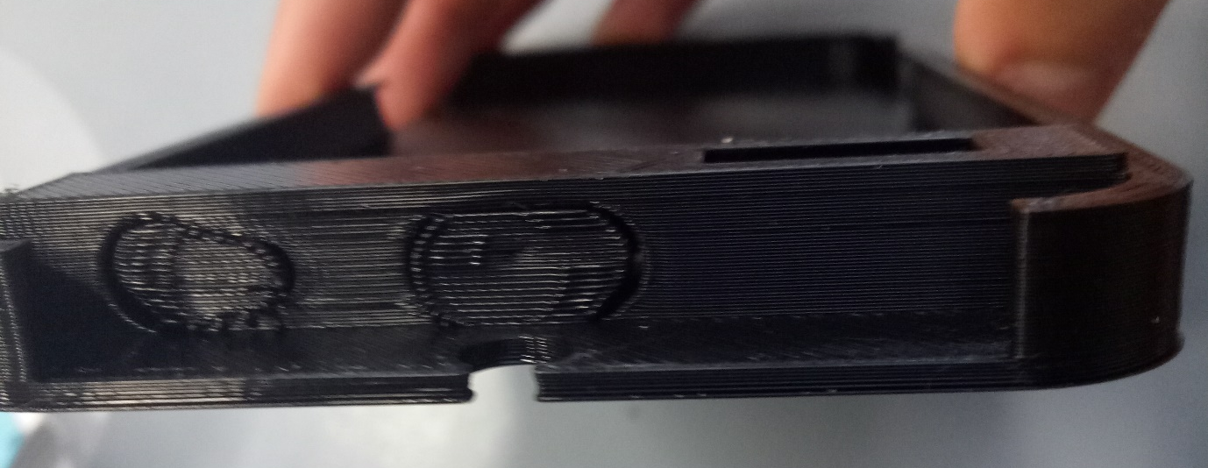
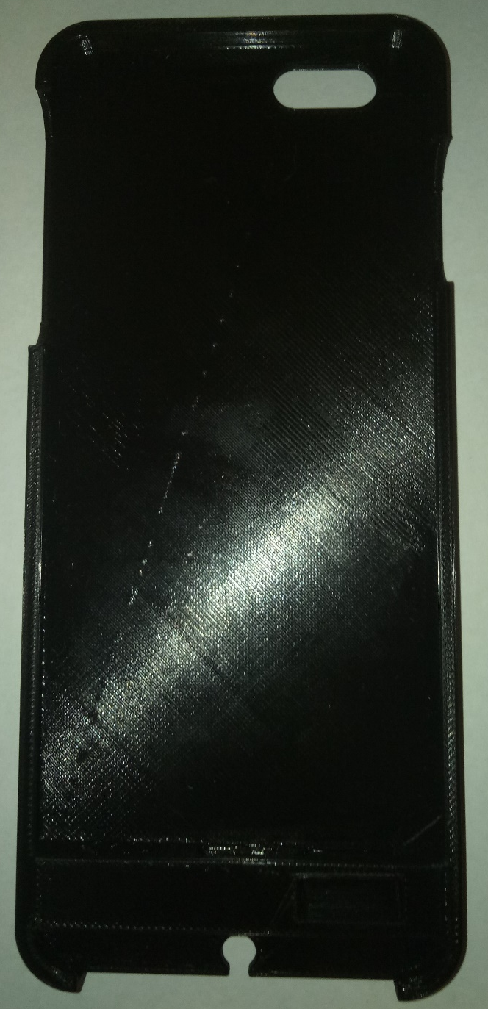
USB Case:

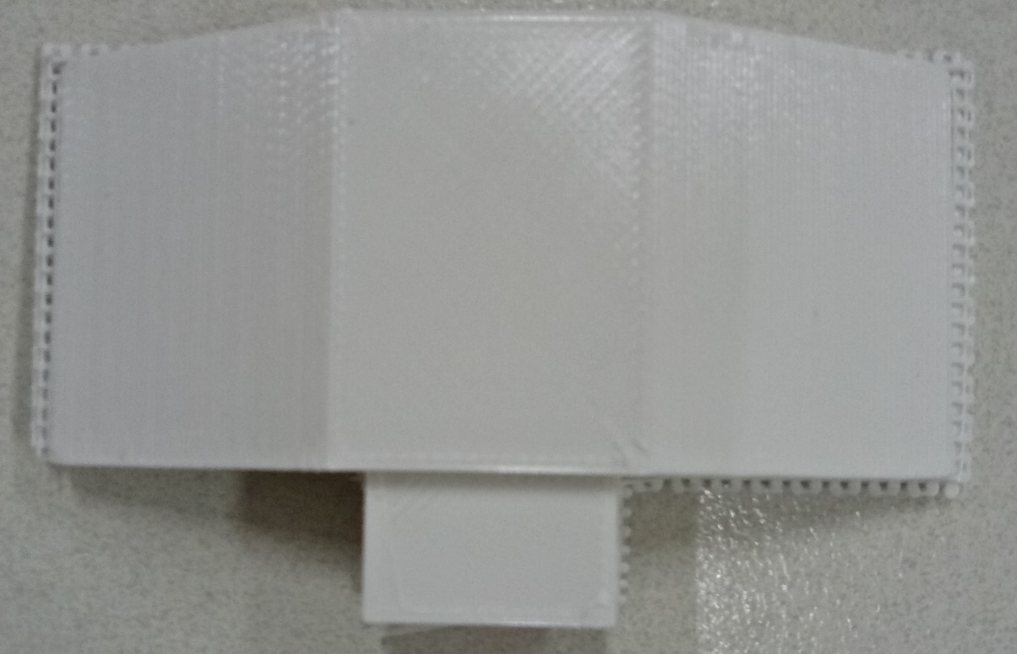

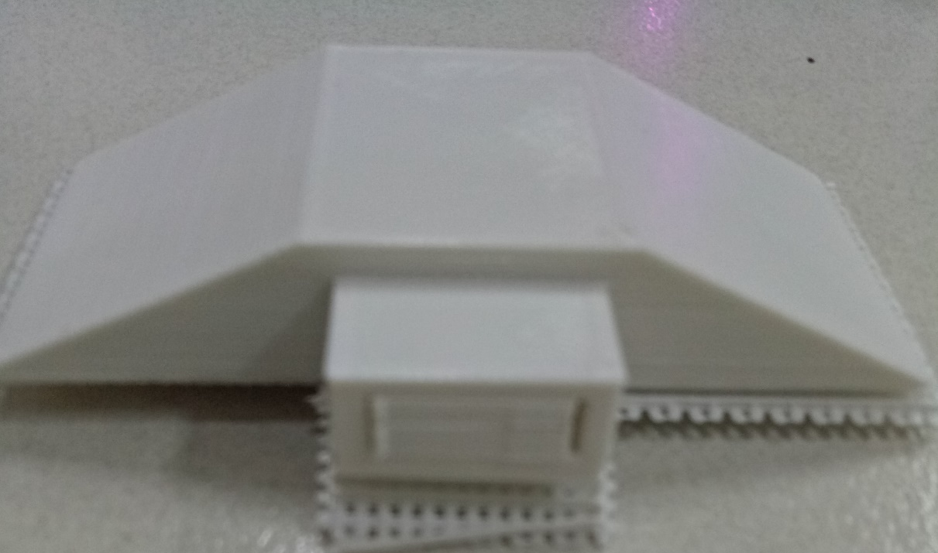

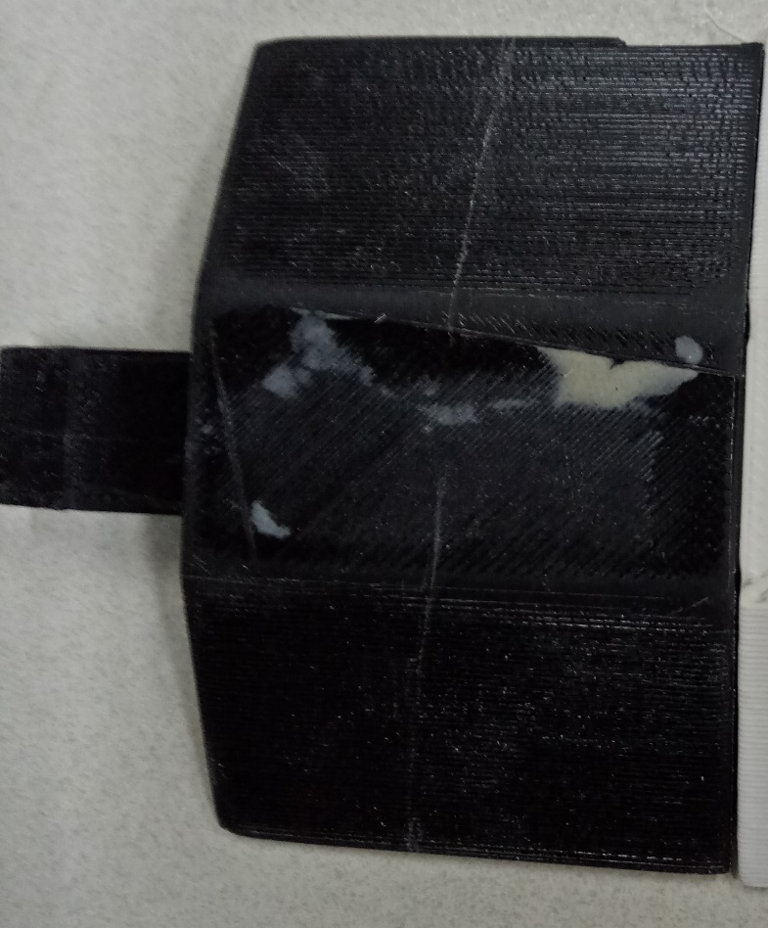
The Back Case:
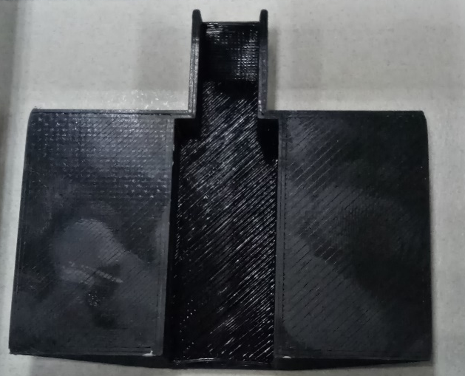

The pieces connecting together:
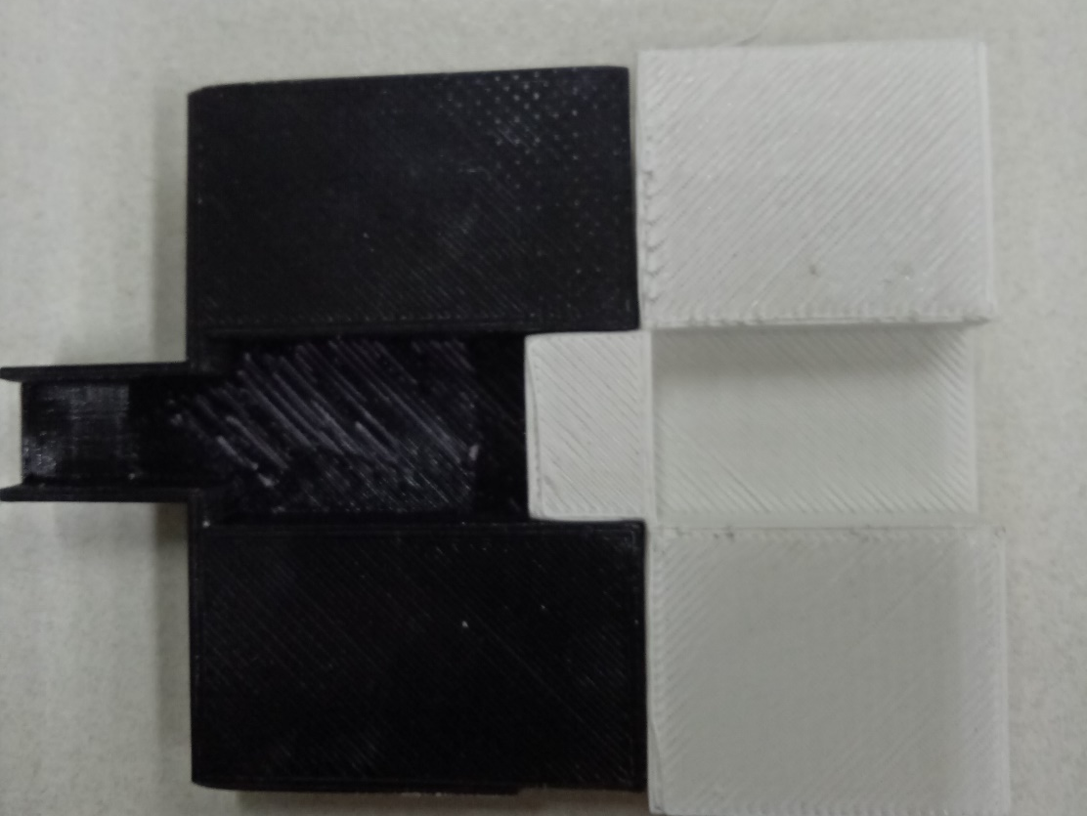
Step 15: Clearing the support of the 3D models and sanding impurities.

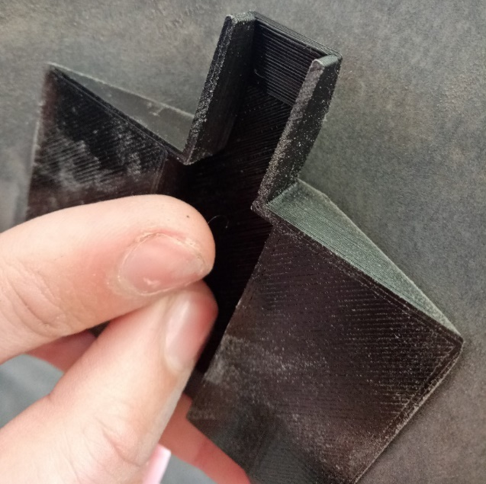
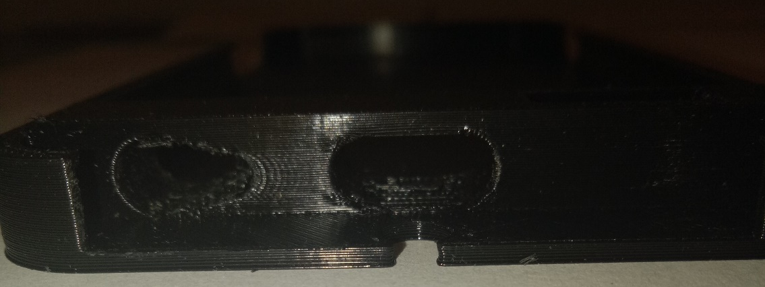
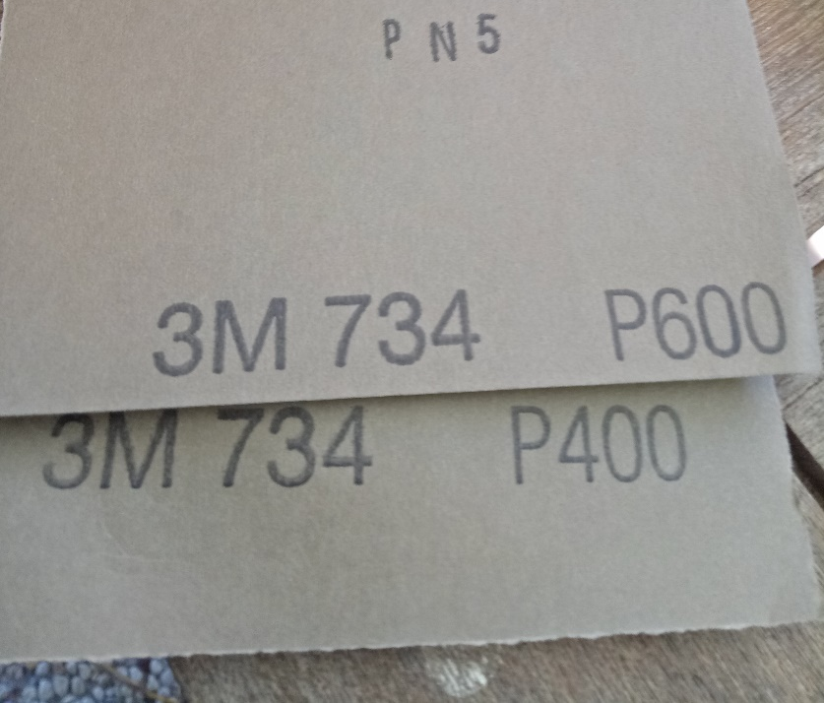
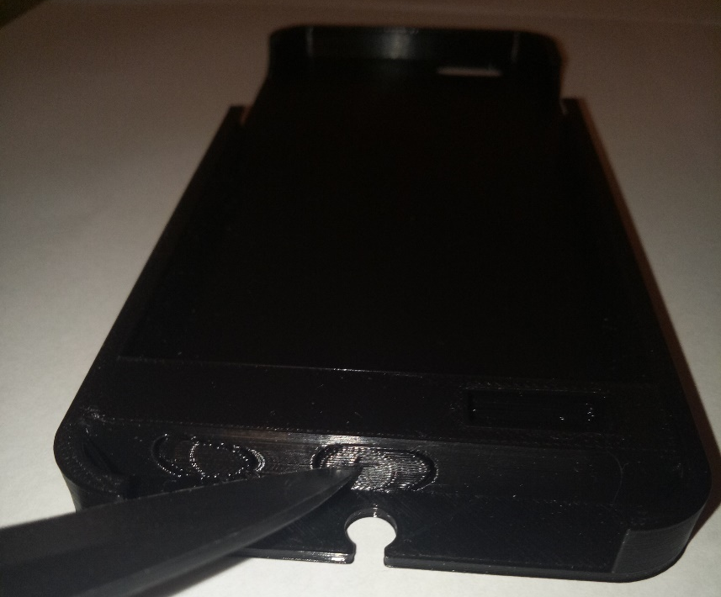
Step 16: Making mould container using acrylic sheet off-cuts and clayette. The acrylic forms a box with the clayette seeling the outside. The 3d printed object is also stuck to the table with a small amount of clay.
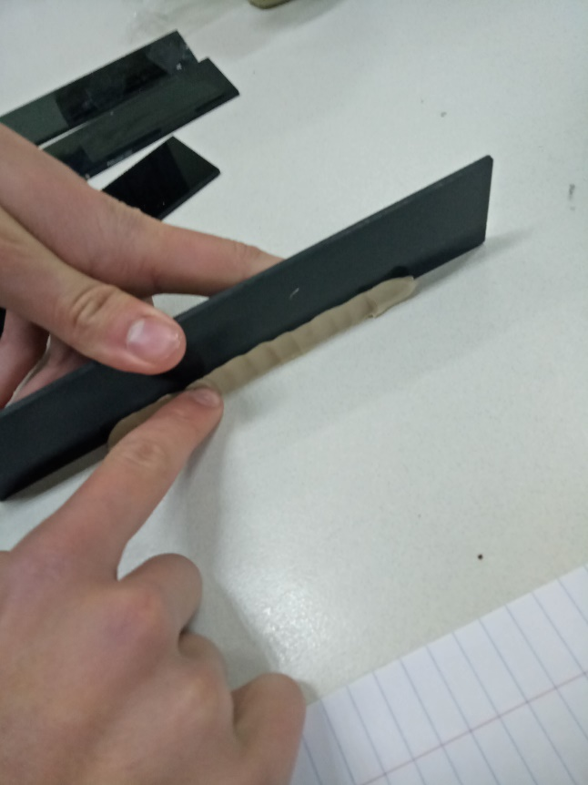
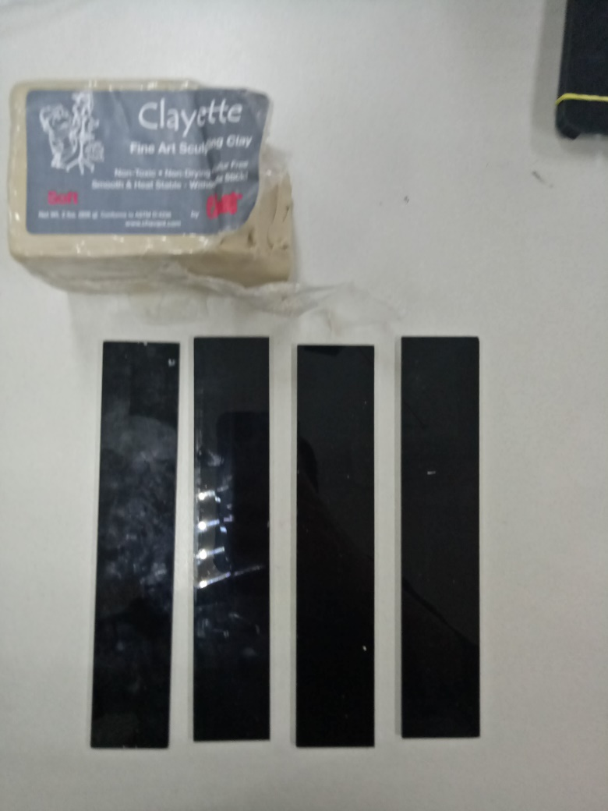

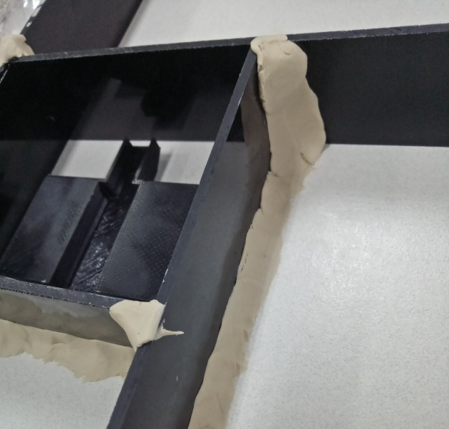
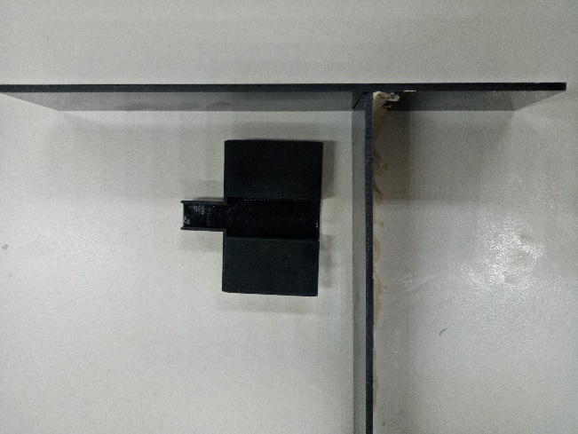
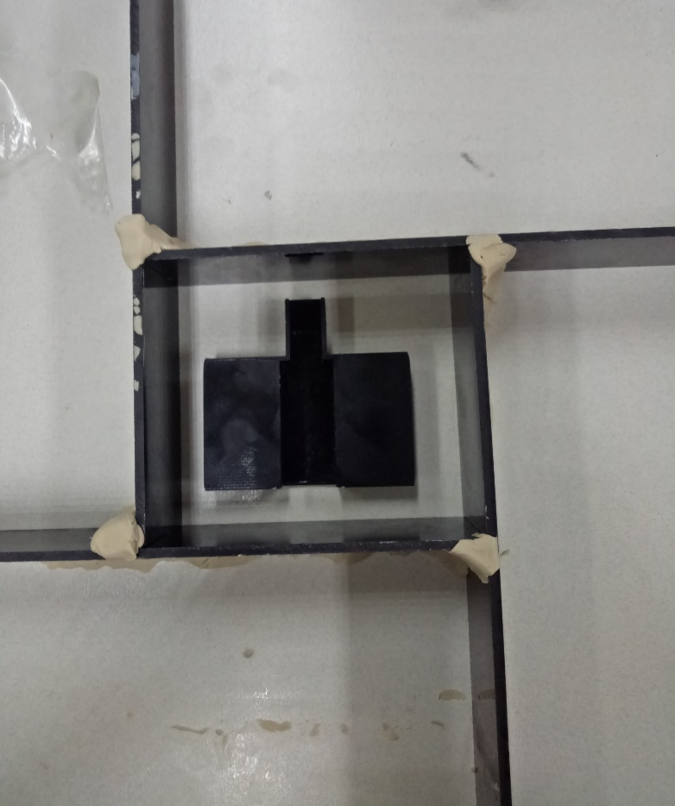
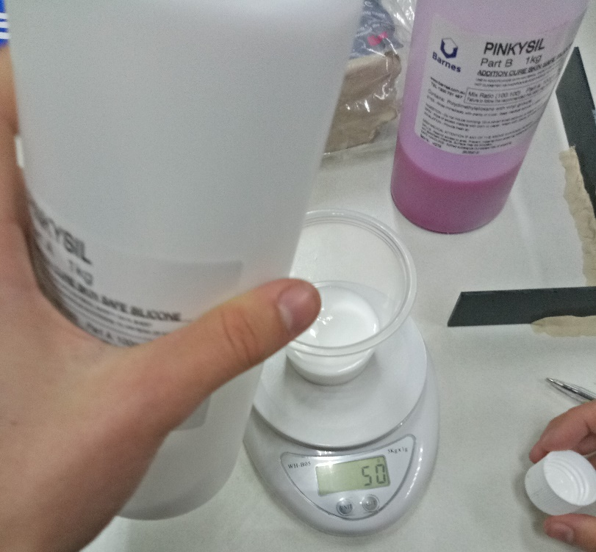
Step 17: Moulding process. The two parts of the Pinkysil mixture were measured 1:1 ratio and poored over the mould in a thin, continuos stream and left to set.

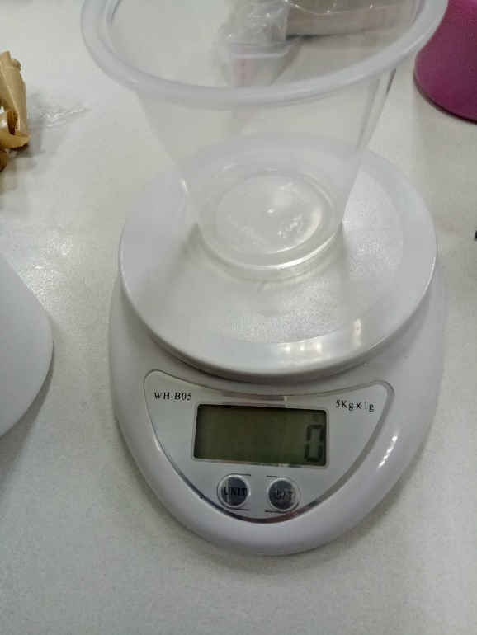
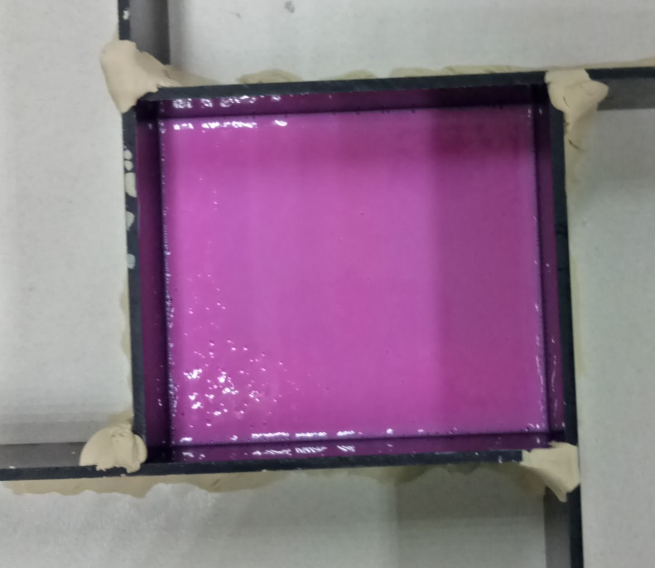
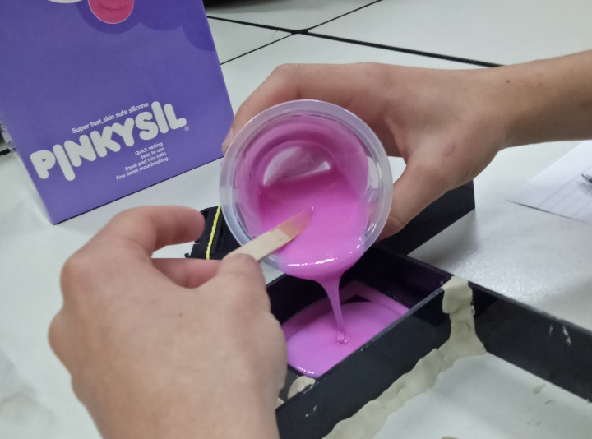

Step 18: Removing object from mould by collecting walls and Clay. A scalpel is needed to cut slits into the top of the mould to remove the object, but keeping the mould intact.
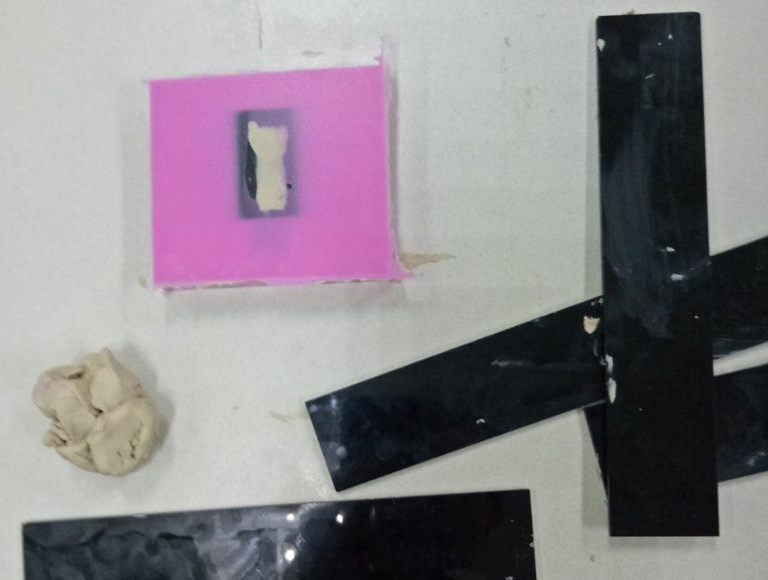
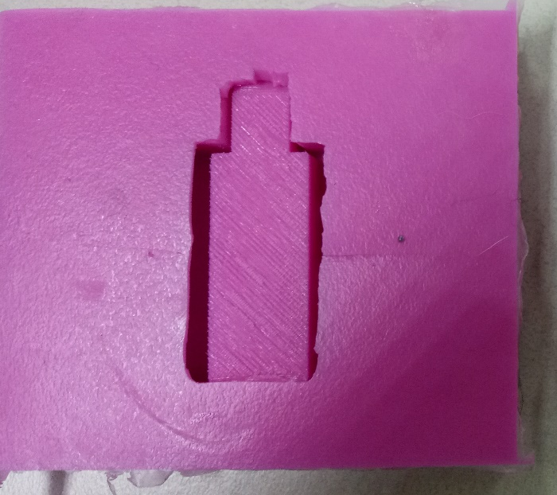

Step 19: Creating second mould for USB case using the same process as the first one. The two parts of the Pinkysil mixture were measured 1:1 ratio and poored over the mould in a thin, continuos stream and left to set.
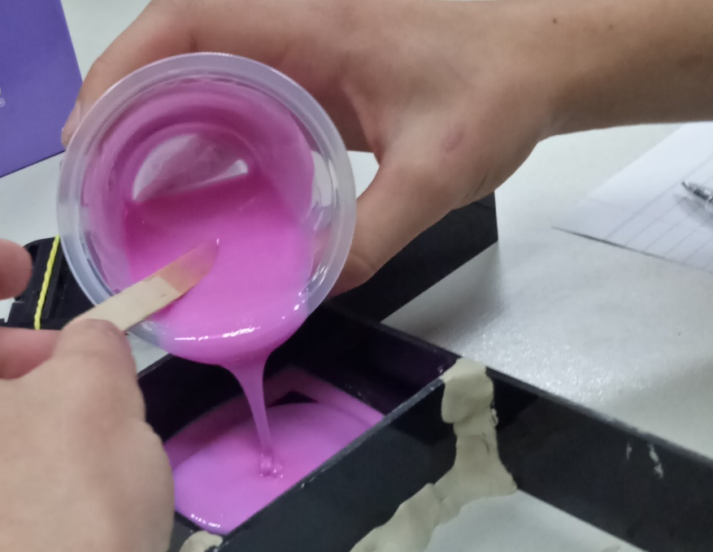

Step 20: Creating the casts. A 1:1 ratio mixture of the ProCast was mixed with black pigment and poured into the back cover piece. After it had set it was removed.
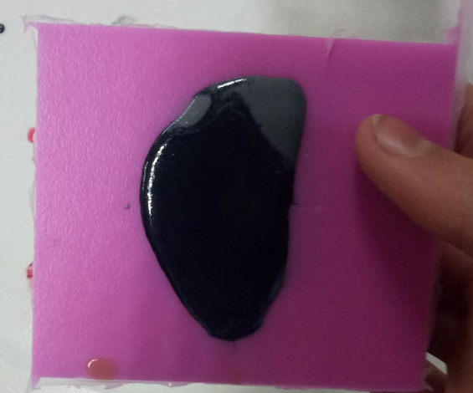
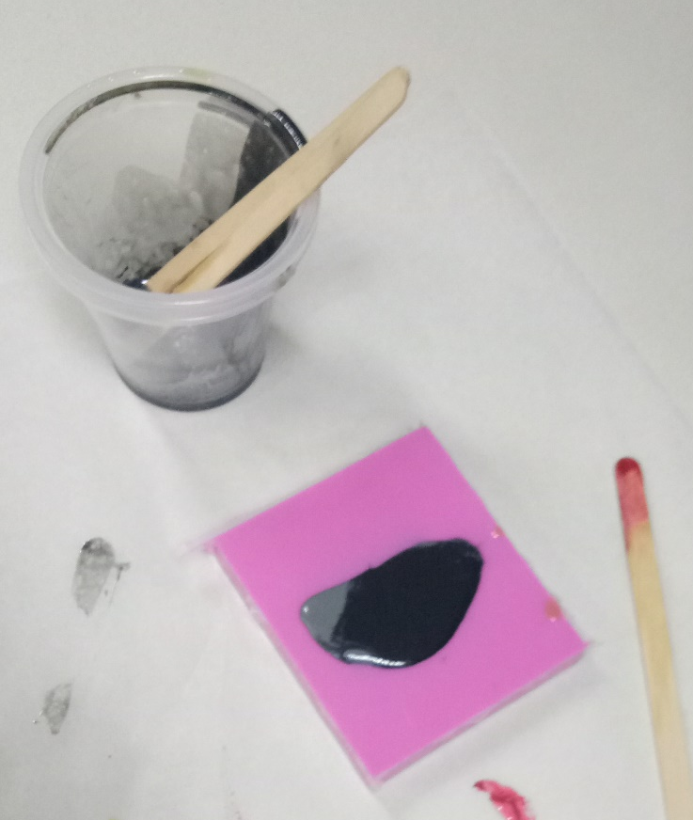

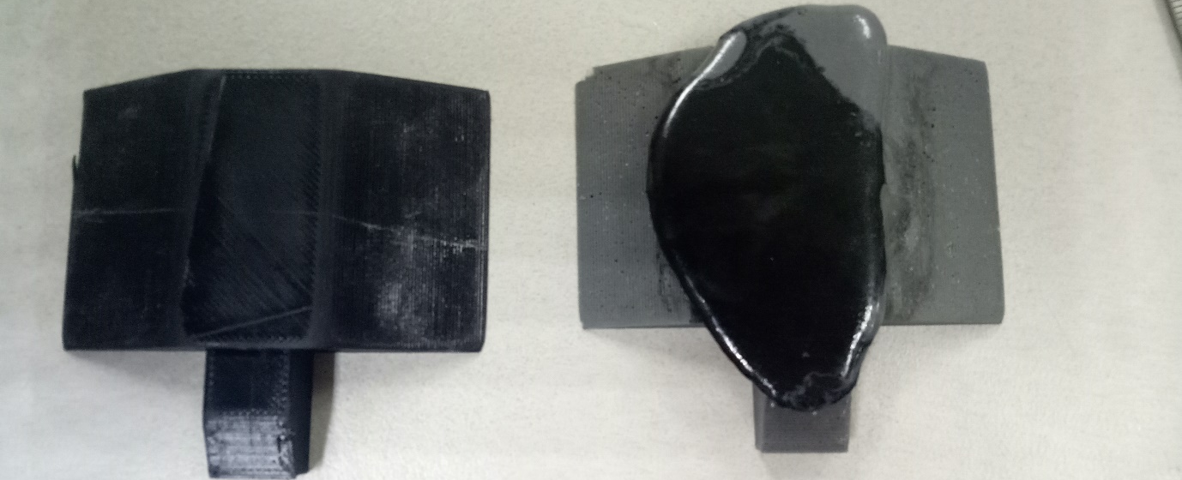
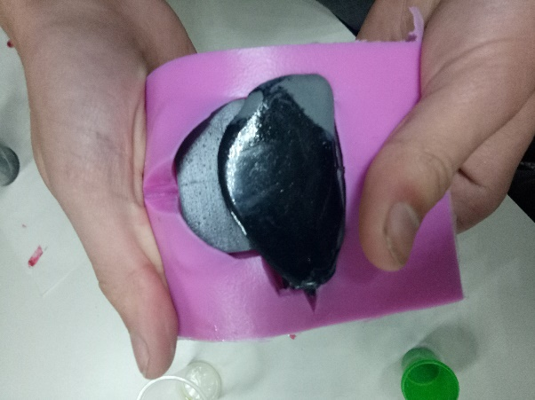
The quality of the cast match the moulded piece very well but the color did not spread properliy, possibly because there wasn’t enough pigment. The cast was sanded to shape.
Castings of USB case:
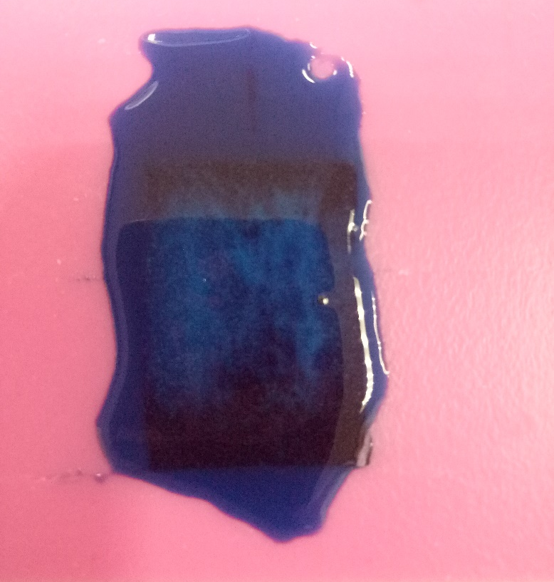
The first two casts didn’t fotm properly as one ad air bubble and the other didn’t set solid.
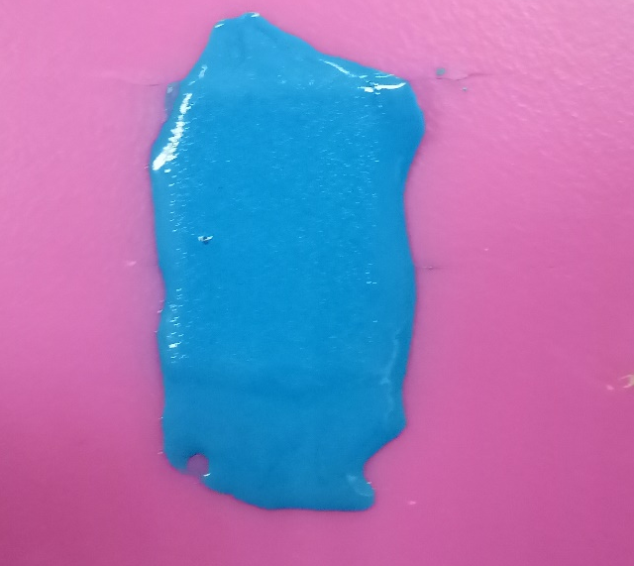

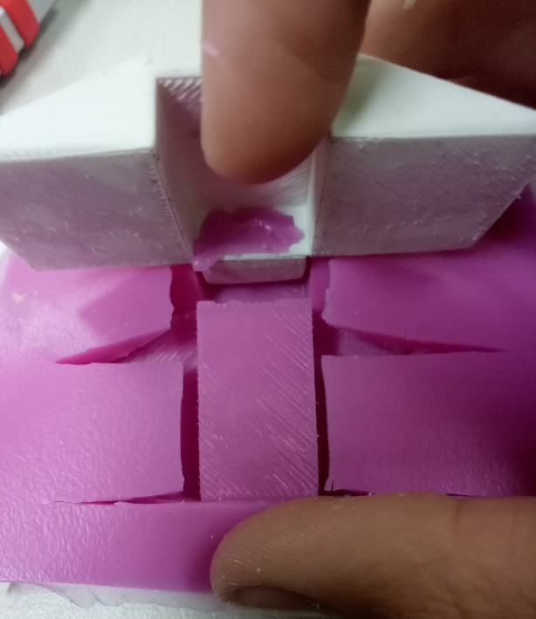
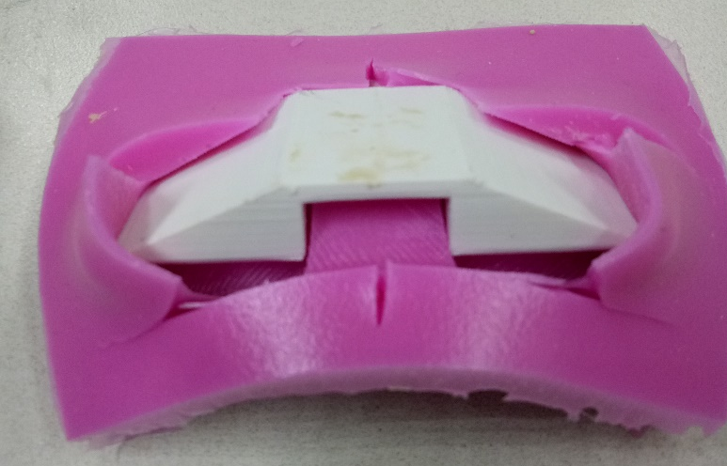
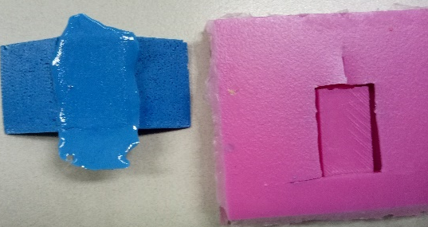
The white mould turned out a lot better than the pervious moulds.
Step 21: The pieces were spray painted glossy black.

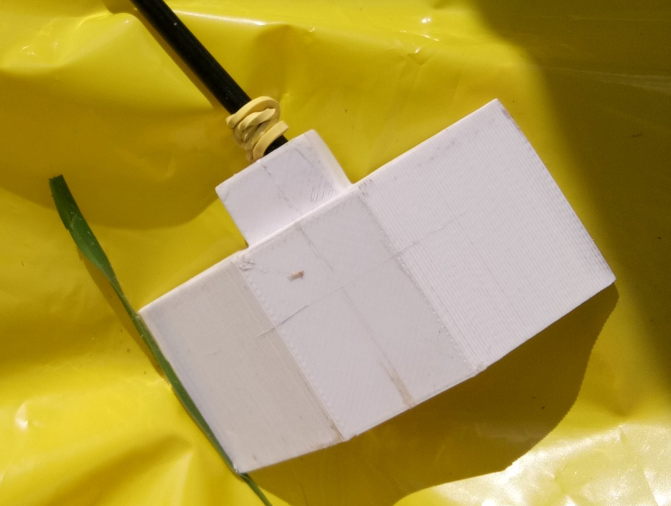
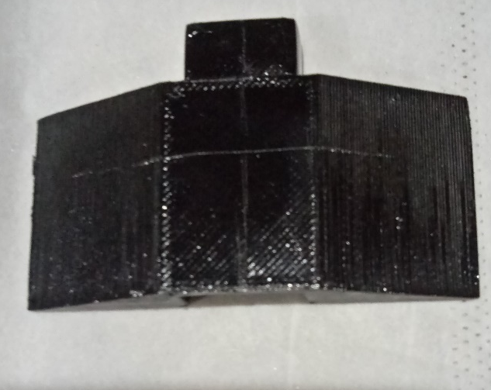
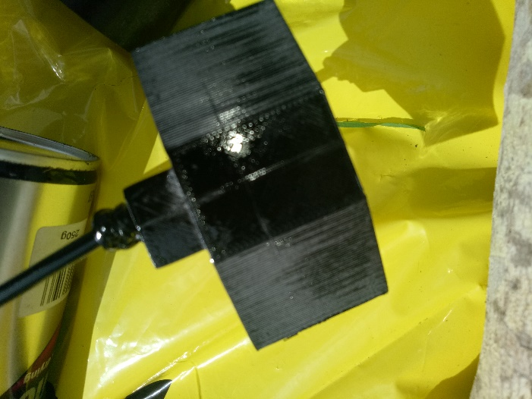
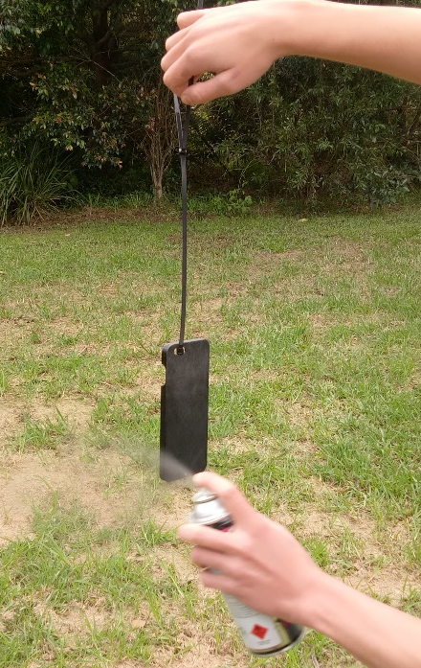
Step 22: The cord was stripped.

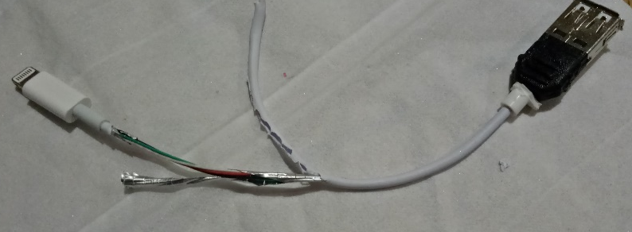
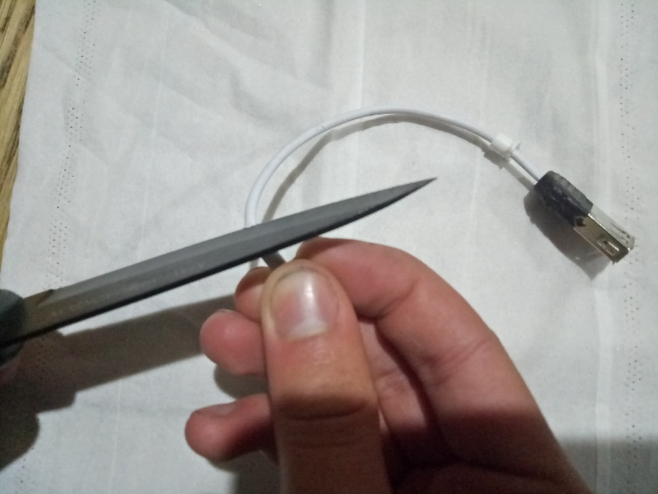

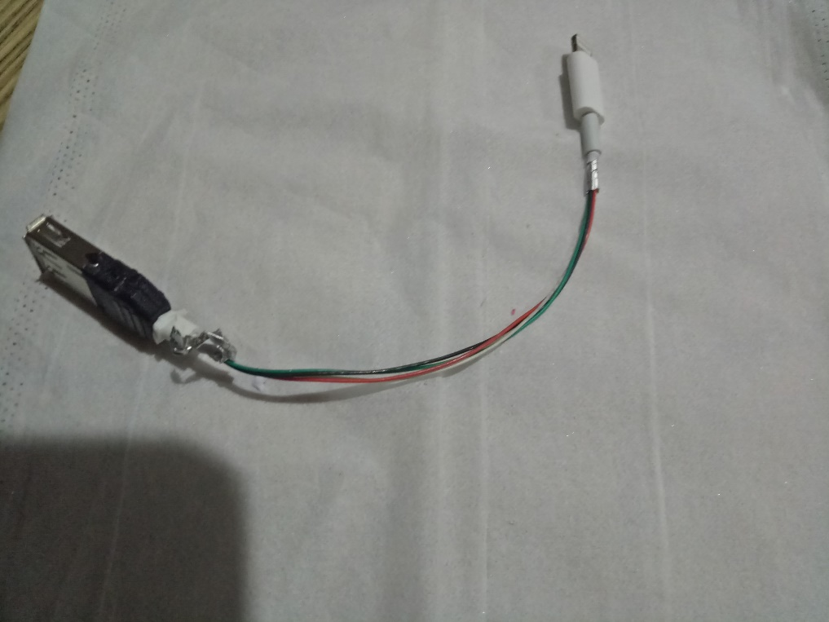

Step 23: The pieces were stuck together with the tow-part epoxy.
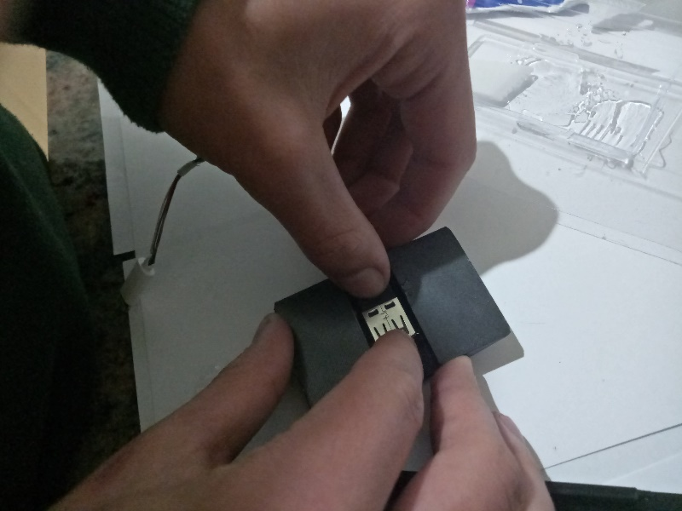
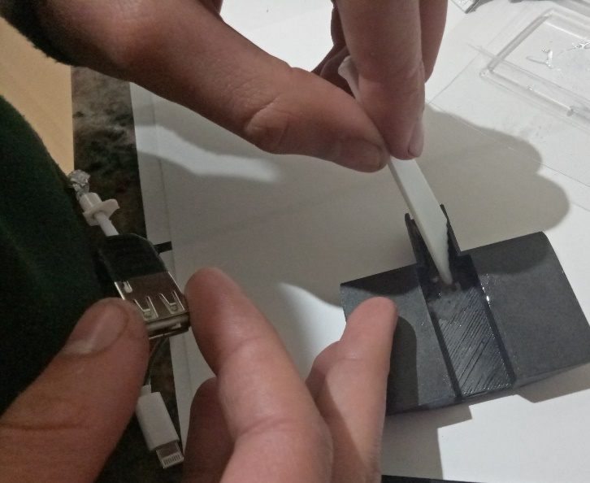

The phone case was sanded with 120 grit sand paper to remove paint on space to glue.

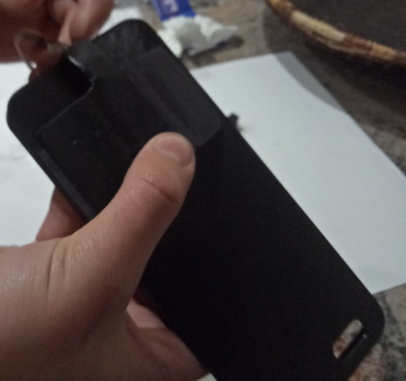
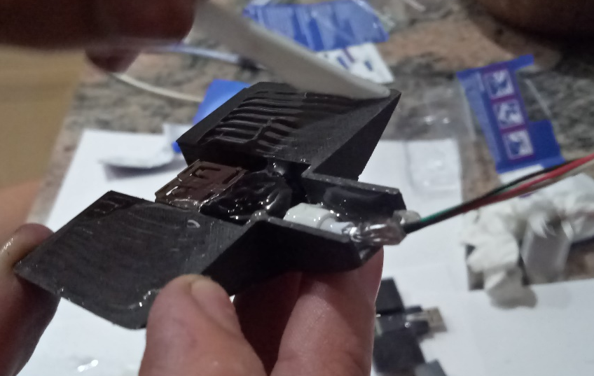
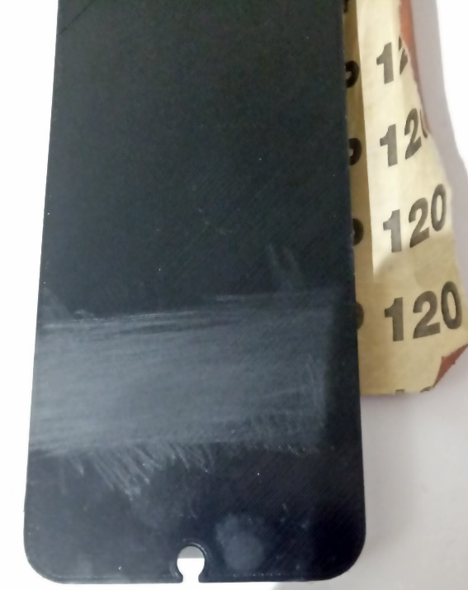
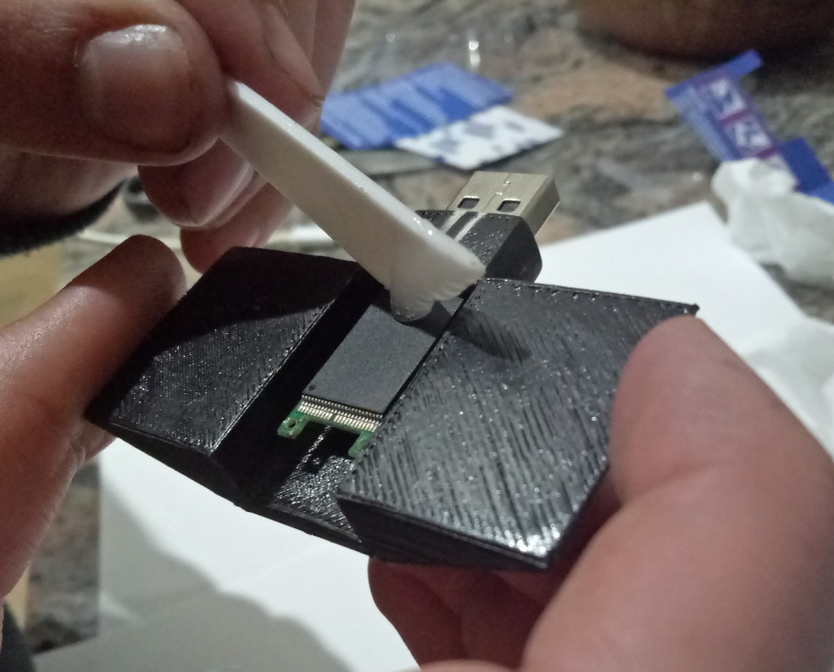

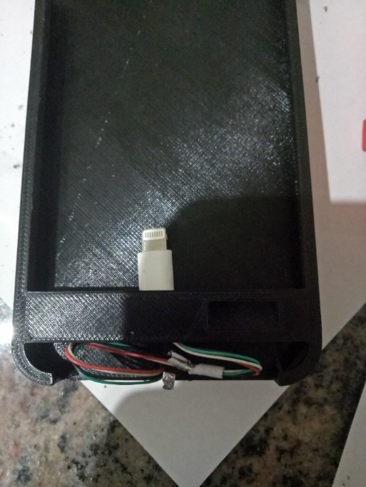
The cord was glued in place.
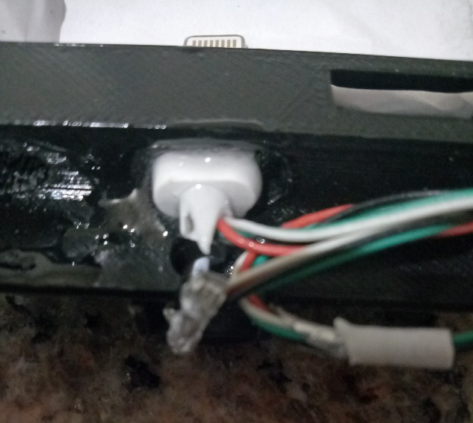

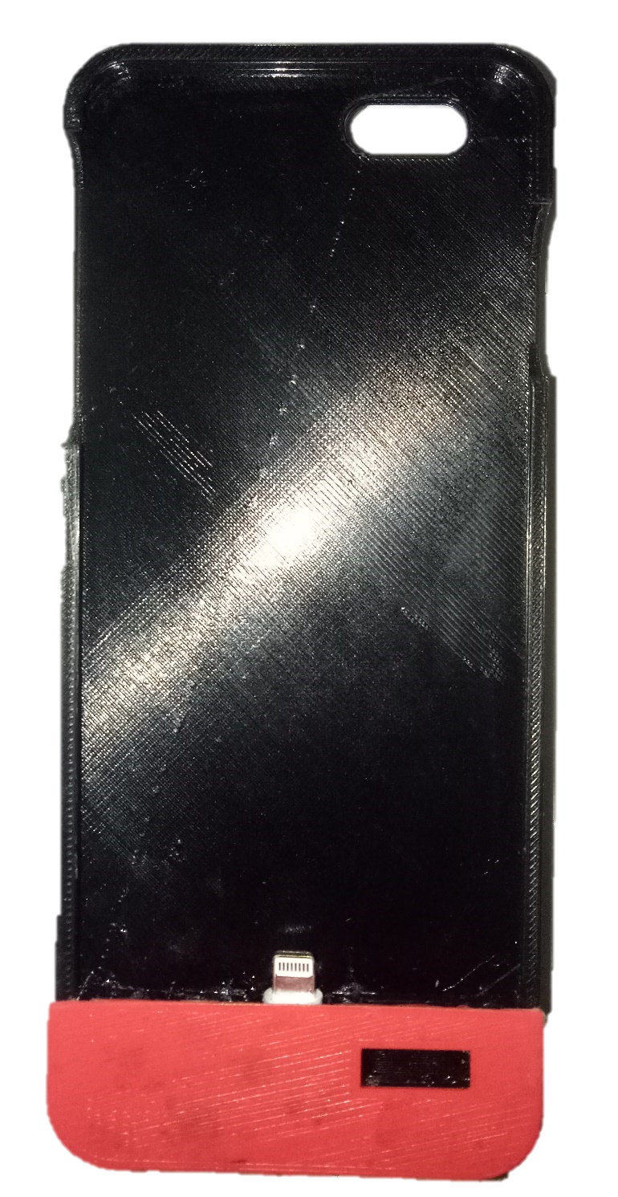
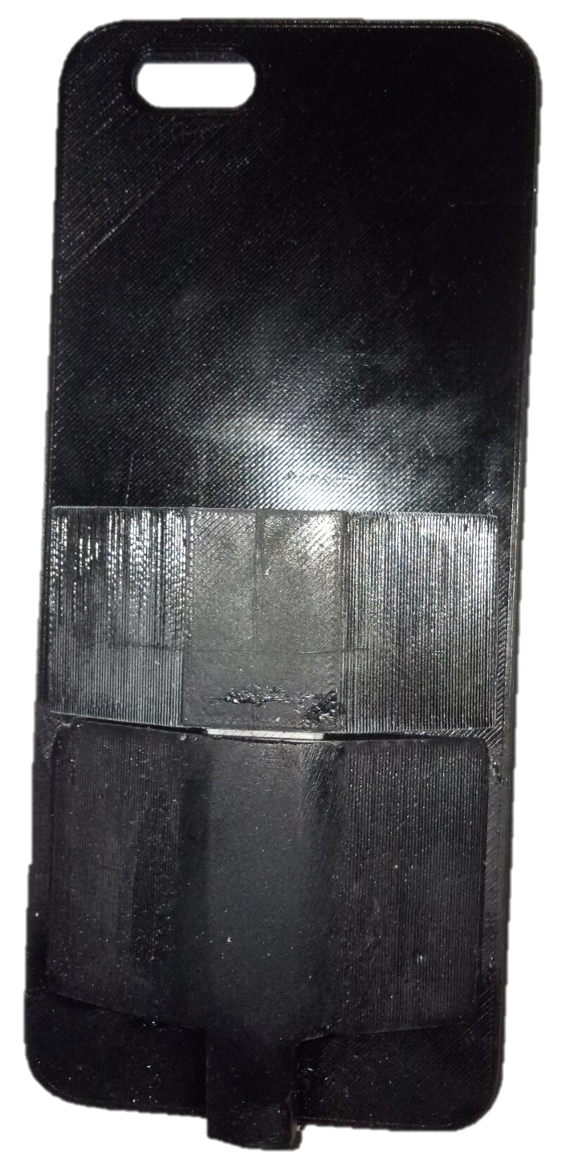
The Product is finished:

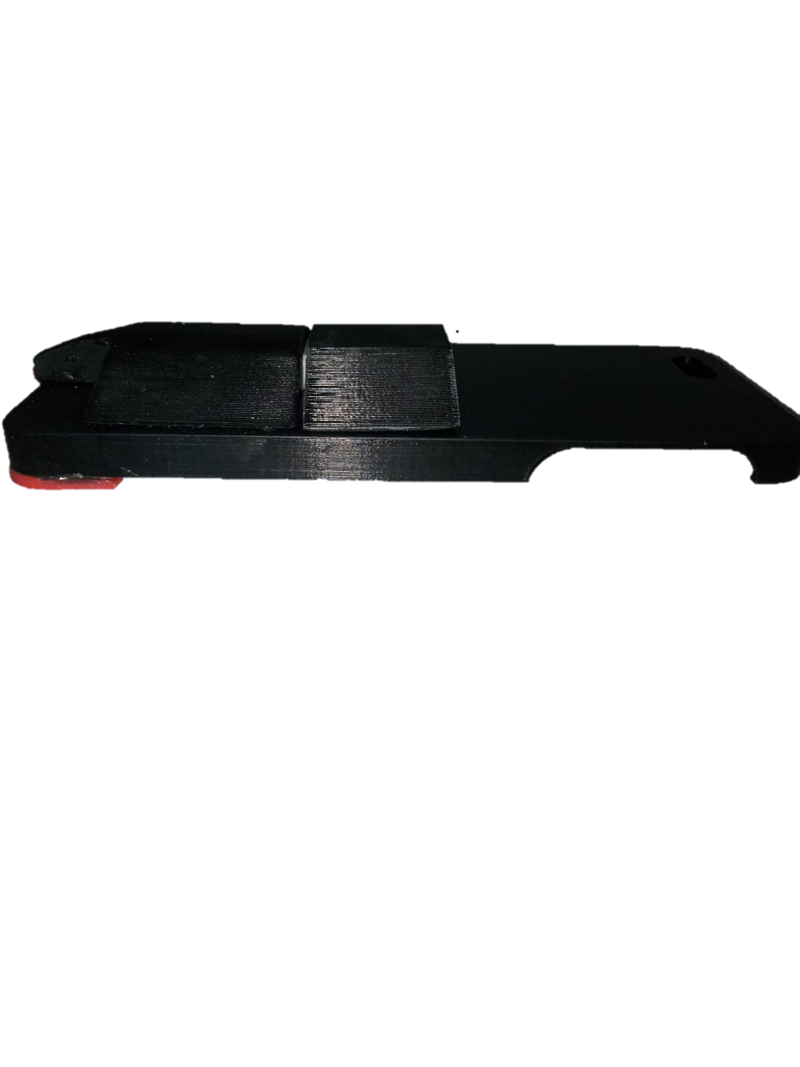
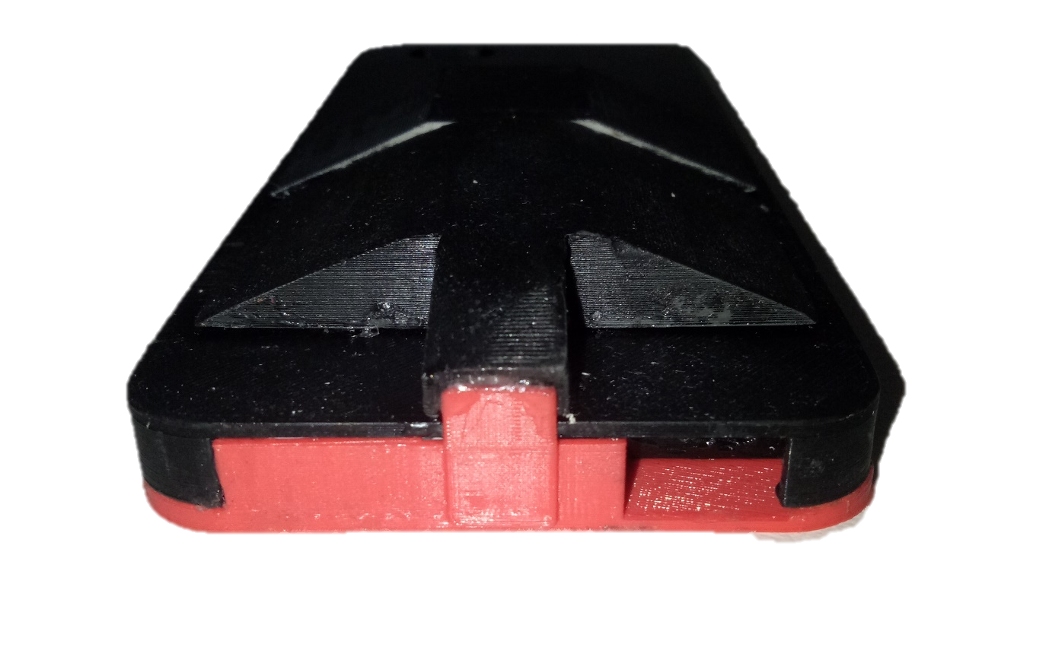
FINAL EVALUATION

The relationship of my final product to my design statement and criteria is strong. The task of creating a new case for a USB is complete, and a higher use is given to the USB through this case so that they can last longer before becoming an idle technology.
If I was to change anything I would make my phone less bulky. The finish on the phone wasn’t too good because of the inexperience and time strain of around 8 weeks.

