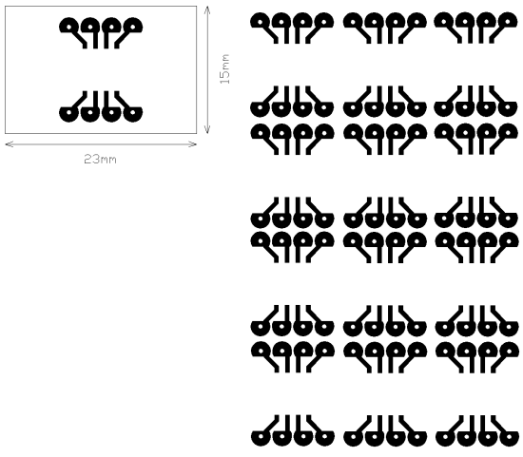

Note: numbers shown are not
Correct, but have been
Scaled here to print correctly.
Print test page and size with
SOIC and DIP chips to confirm.

