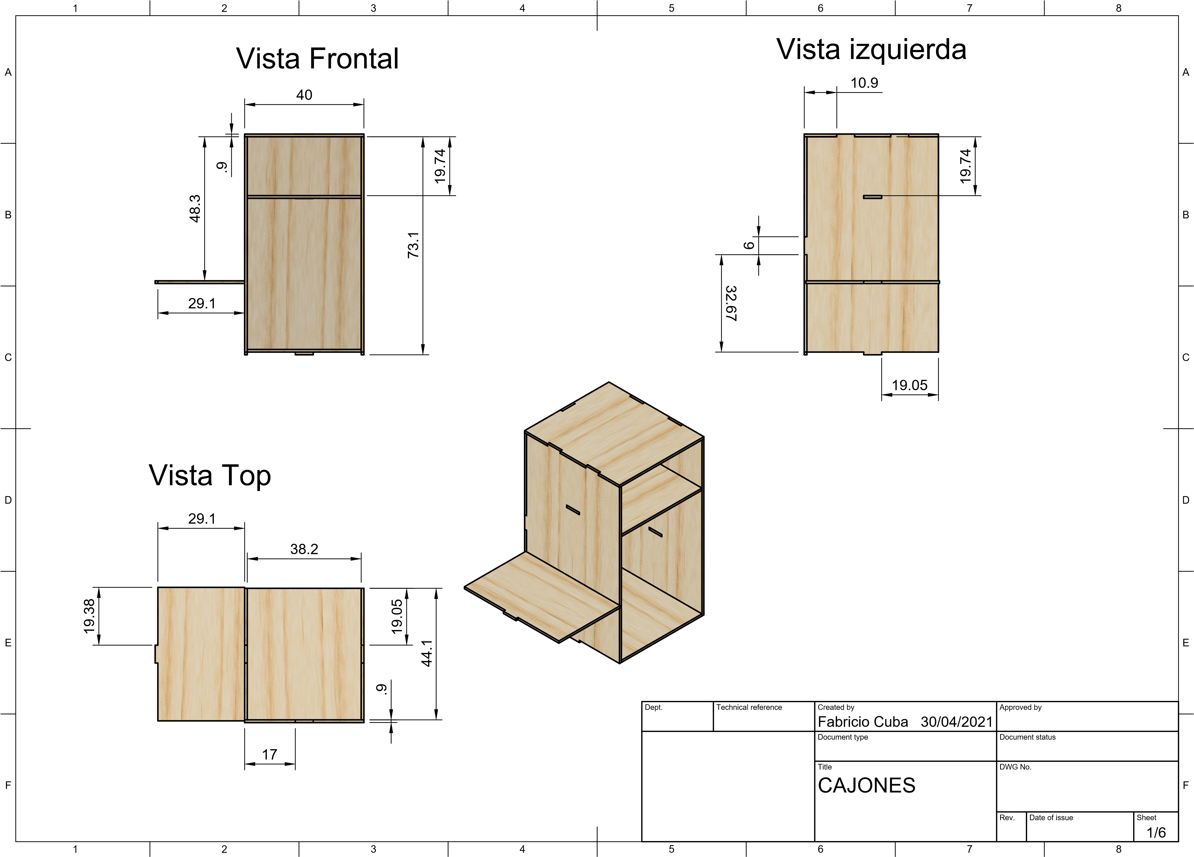
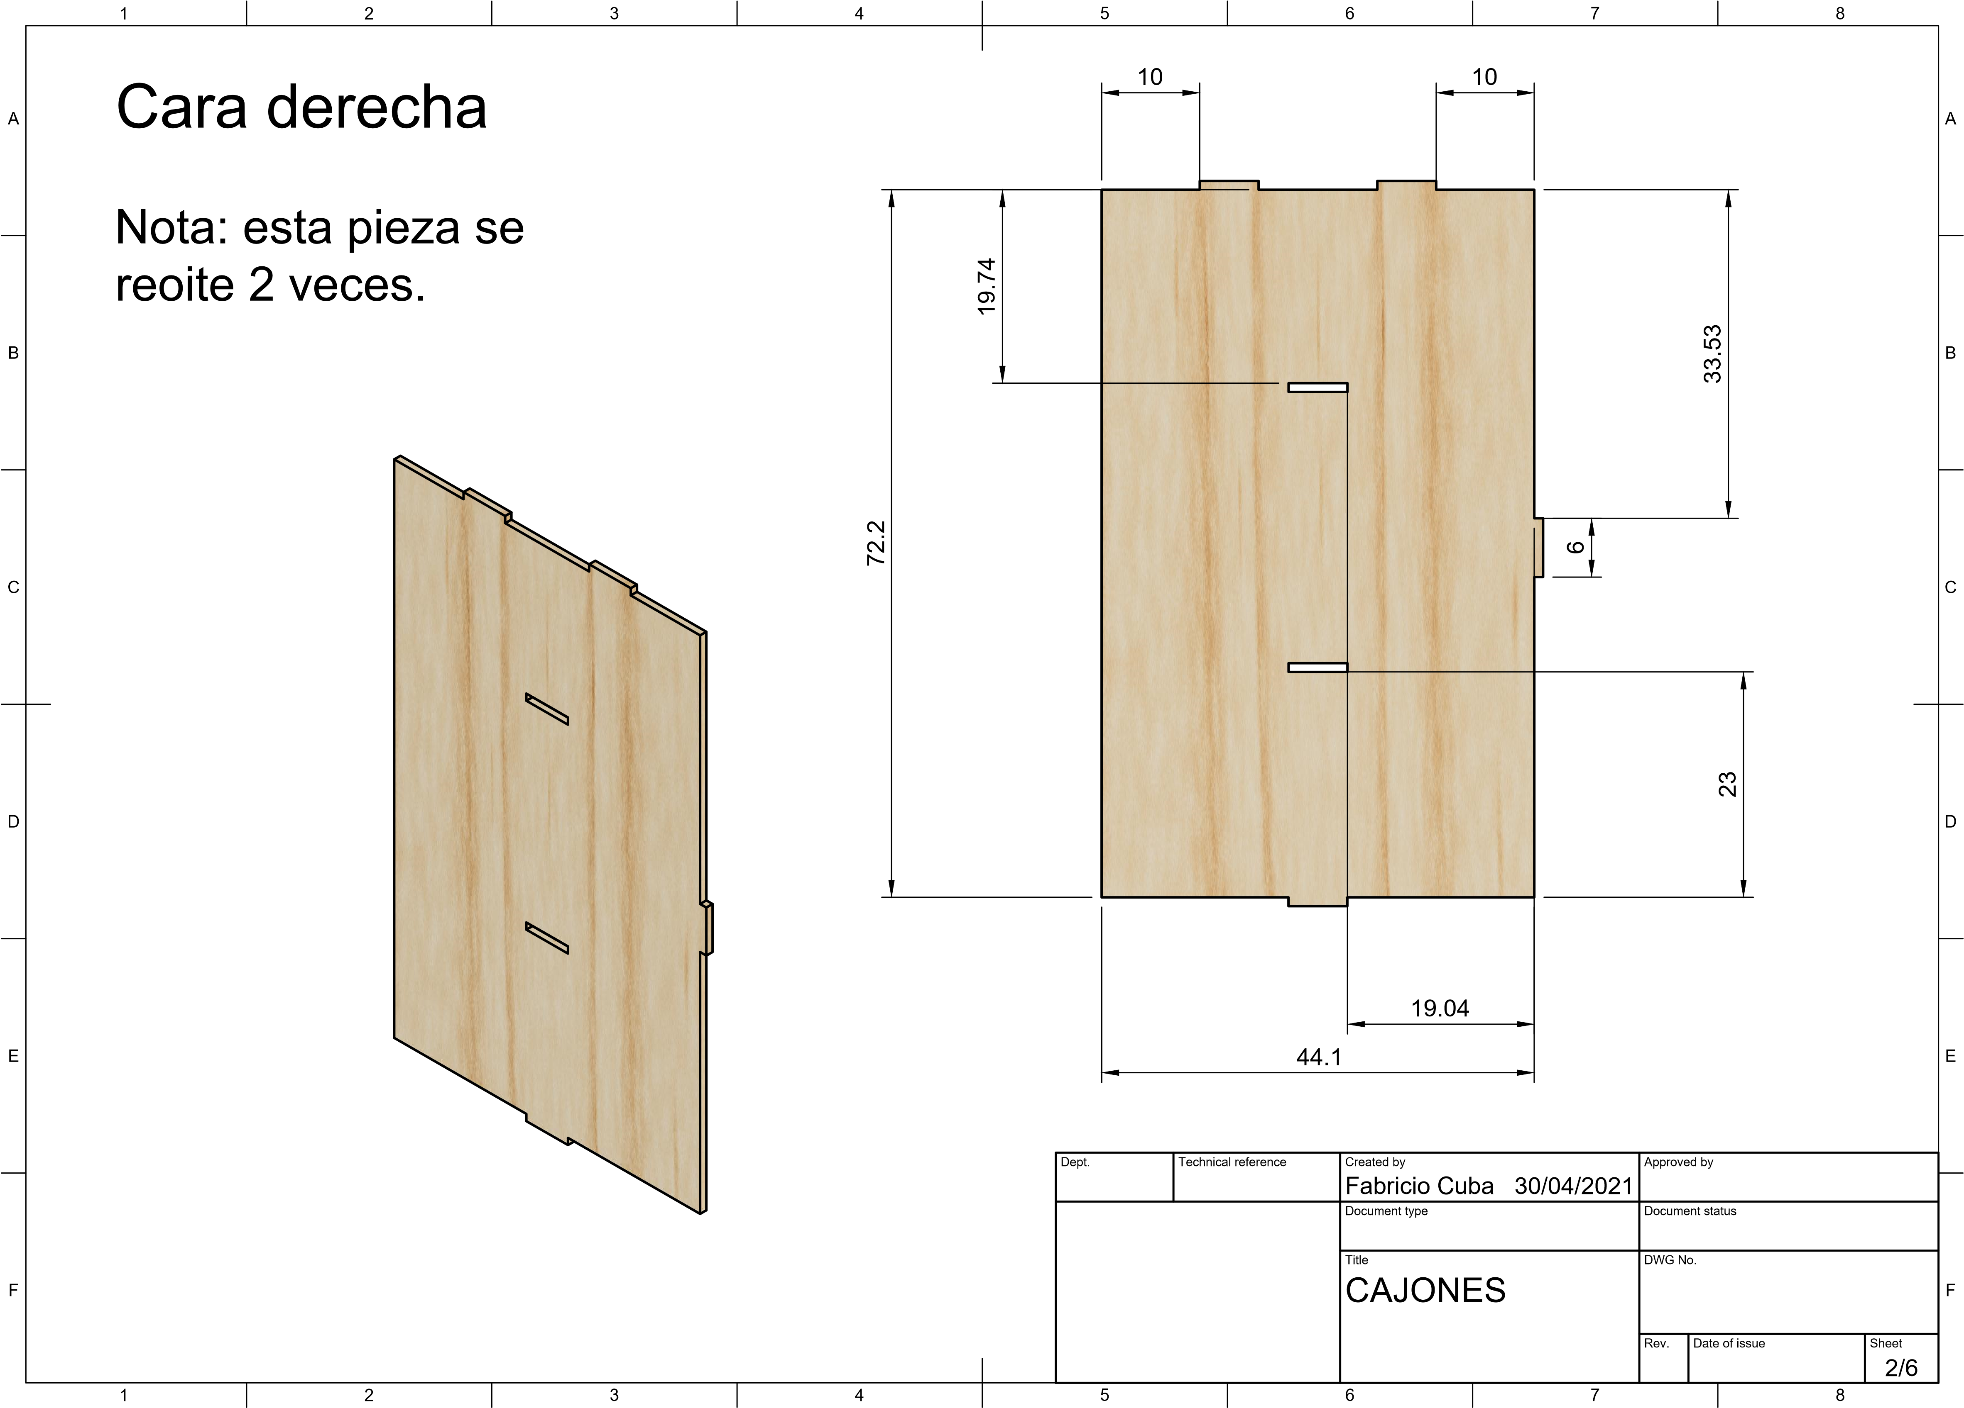

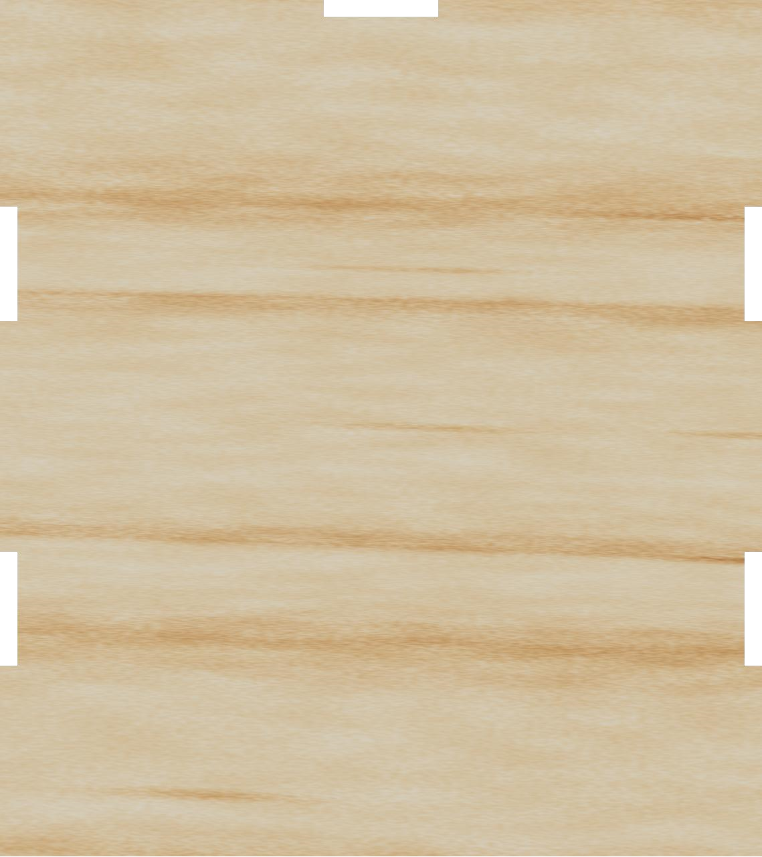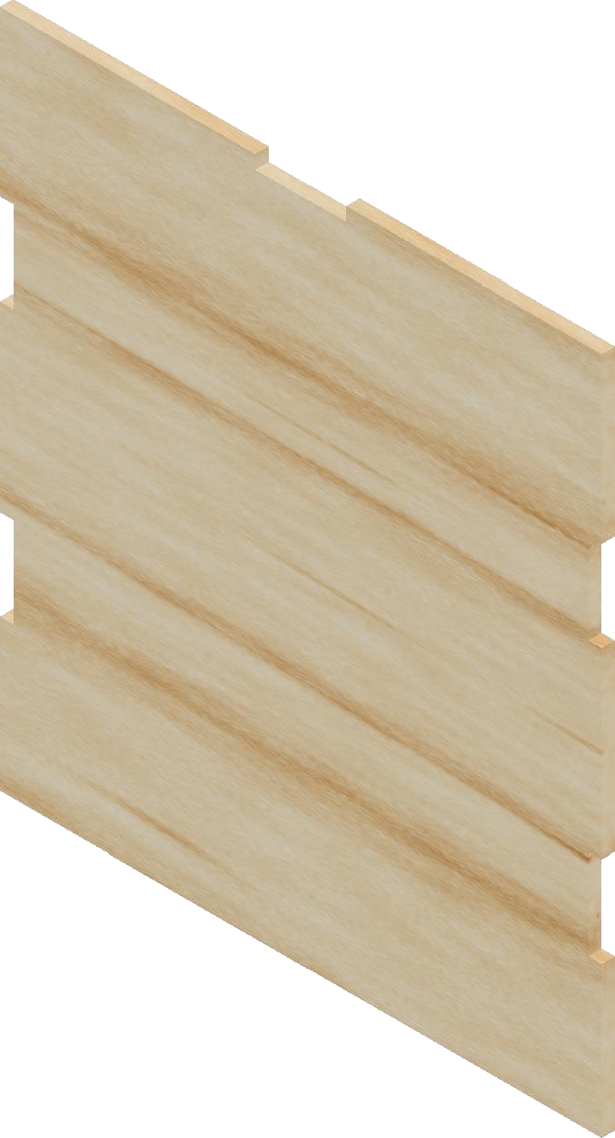
Dept.
Technical refe
rence
Created by
Approved by
Document type
Document status
Title
DWG No.
Rev.
Date of issue
Sheet
30/04/2021
/
6
3
CAJONES
Fabricio Cuba
17
10.9
10
6
40
12.1
45
Cara superior
Nota: esta pieza
se repite 2
veces, superior y
inferior.
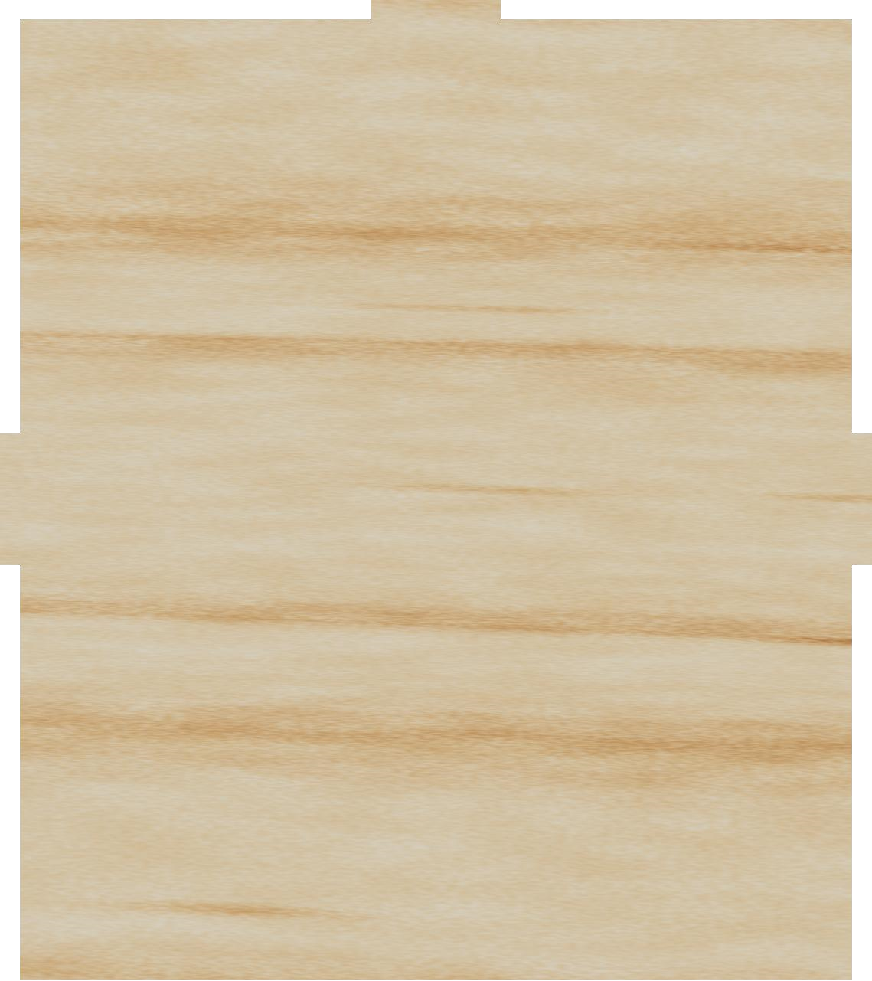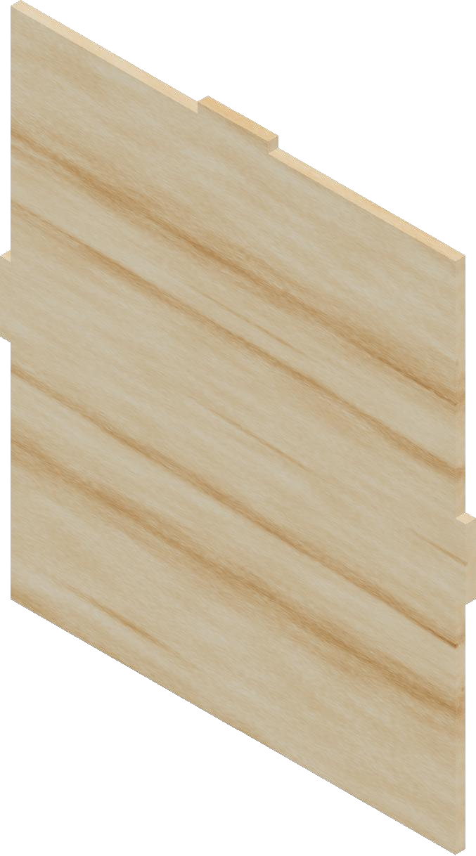
Dept.
rence
Technical refe
Created by
Approved by
Document type
Document status
Title
DWG No.
Rev.
Date of issue
Sheet
30/04/2021
/
6
4
CAJONES
Fabricio Cuba
^{16.1}
19.05
19.05
38.2
16.1
6
44.1
Cara interior
Nota: esta pieza
va al interior de
los cajones
como divisor.

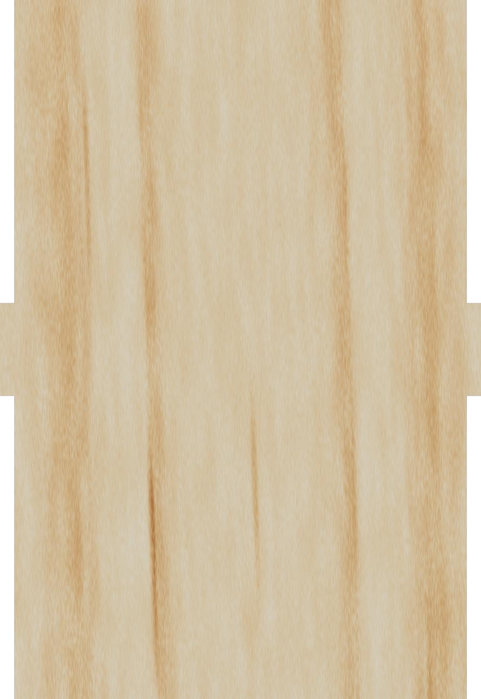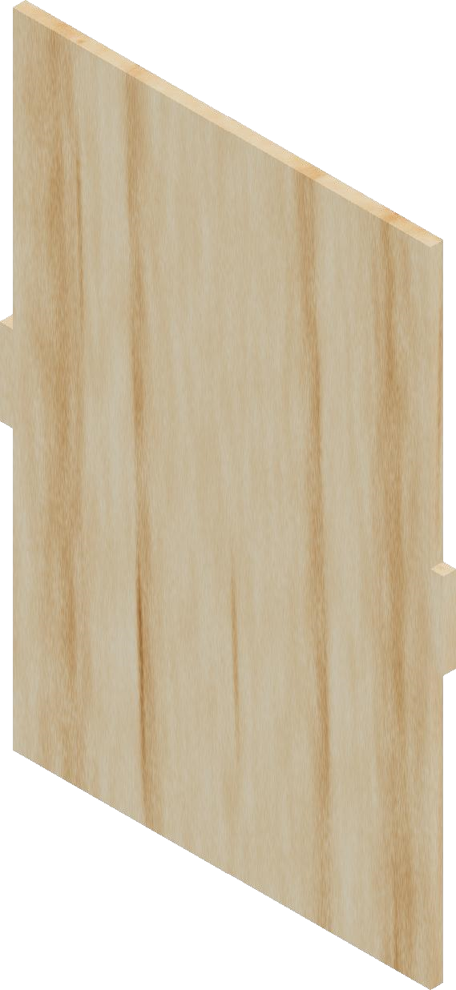
Dept.
al reference
Technic
Created by
Approved by
Document type
atus
Document st
Title
DWG No.
Rev.
e of issue
Dat
Sheet
30/04/2021
6
5
/
ES
CAJON
ba
Fabricio Cu
1
A
2
3
4
5
6
7
8
1
2
3
4
5
6
7
8
B
C
D
E
F
A
B
C
D
E
F
29
.1
19.38
6
44.76
al
Cara later
